MOUNT LITERA ZEE SCHOOL CONTAI
ANNUAL REPORT
2022-23

Mount Litera Zee School, Contai (WB)
Affiliation No. 2430183 School Code 15667
Address- Srirampur, Contai, East Midnapur, Pin: 721401
Ph No: 91-8420049907 91-3220-288-511
Affiliation Status-Provisional Period of Affiliation 2019-24

MLZS, Contai aims to be the centre of excellence in education using the state of the art of technology where the seeds of the all-round development of the children are sown at an early age. Thus, we take immense pleasure and pride to present to you a report of our activities and achievements for the year 2022-23.

School Philosophy: The school focuses not only an advanced academics but also on excellent curricular and co - Curricular activities. Students are trained at a very young age towards incorporating a sense of responsibility, loyalty, tram spirit, healthy competition to become graceful dignified personalities.

Vision:
Our founder had the desire to create a dynamic environment to bring out the best of every student in a holistic manner. With learnings focused on the complete development of a child, MlZS envisions to be the foundation for creating wish leaders rooted in their ethnicity and culture to create a better future for all.

Mission:
Our mission is to achieve the holistic development of student through an excellent academic and physical environment that is conductive to learning developing creativity, exploration. To create healthy strong, bold, disciplined, bold and competent citizens who will work for the betterment of the Nation. The academic year began with a prayer service and all new joined were welcomed to our school family.

Our-Core-Values
At the core of everything we do at MOUNT LITERA ZEE SCHOOL is one simple principle—what’s Right for the Child (WRFC). Through that mantra we filter all our decisions and actions. WRFC helps us keep the child at the centre of everything we do and ensures single- minded devotion to her growth and development.
It has been a constant endeavor of the school to incubate young minds into citizens of tomorrow and fulfill its mission statement. The true essence of education lies in creating good human beings and MLZS, CONTAI, strives to garnish the young minds with the three E’S
EDUCATE——— EVOLVE——– EMPOWER

“TOGETHER WE CAN; WE WILL”
This year has been a very eventful one for us. We have made great efforts to transform ourselves completely into the CBSE’s updated scholastic format and have been extremely successful in most of our endeavors. Apart from preparing the children to qualify for purely academic demands, special efforts are being made continuously to enable them to face the challenges of the competitive world. It’s a matter of great importance to us that the students who pass out from our portals should carry forward the values they have inherited, excel in whatever they do and be role models in the society.
In Mount Litera Zee School, we believe that every individual has a lot of potential, and that potential can help accomplish wonders. That is why; it is fair to say that we thus believe that the future of the world starts here. The session of 2022-23 was a great year, and we consider it a moment of pride to showcase to you all the achievements and development that the school, staff and students undertook.

“Reach high, for stars lie hidden in your soul. Dream deep, for every dream leads to the goal.”

School’s strength- The school currently has strength of Students 797, Academic staff 52, Office and Support Staff 18, Notice Served-20.

NUMBER OF STUDENTS

SR.NO | CLASS | TOTAL NUMBER OF STUDENTS
1 | NURSERY | 24
2 | JR.KG | 26
4 | SR.KG A | 27
5 | SR.KG B | 26
6 | I A | 28
7 | I B | 31
8 | II A | 31
9 | II B | 30
10 | III A | 30
11 | III B | 29
12 | IV A | 26
13 | IV B | 26
14 | V A | 30
15 | VB | 31
16 | VI A | 31
17 | VI B | 31
18 | VII A | 40
19 | VII B | 40
20 | VIII A | 36
21 | VIII B | 35
22 | IX A | 29
23 | IX B | 30
24 | X | 38
25 | XI- Science | 48
26 | XI- Commerce | 11
27 | XI- Humanities | 03
28 | XII- Science | 39
29 | XII- Commerce | 01
30 | XII- Humanities | 01
 | TOTAL | 797

BOARD RESULTS
CLASS X
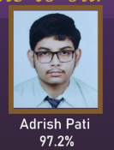
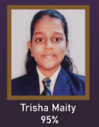
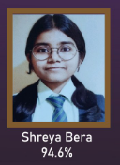

ADRISH PATI
TRISHA MAITY
SHREYA BERA
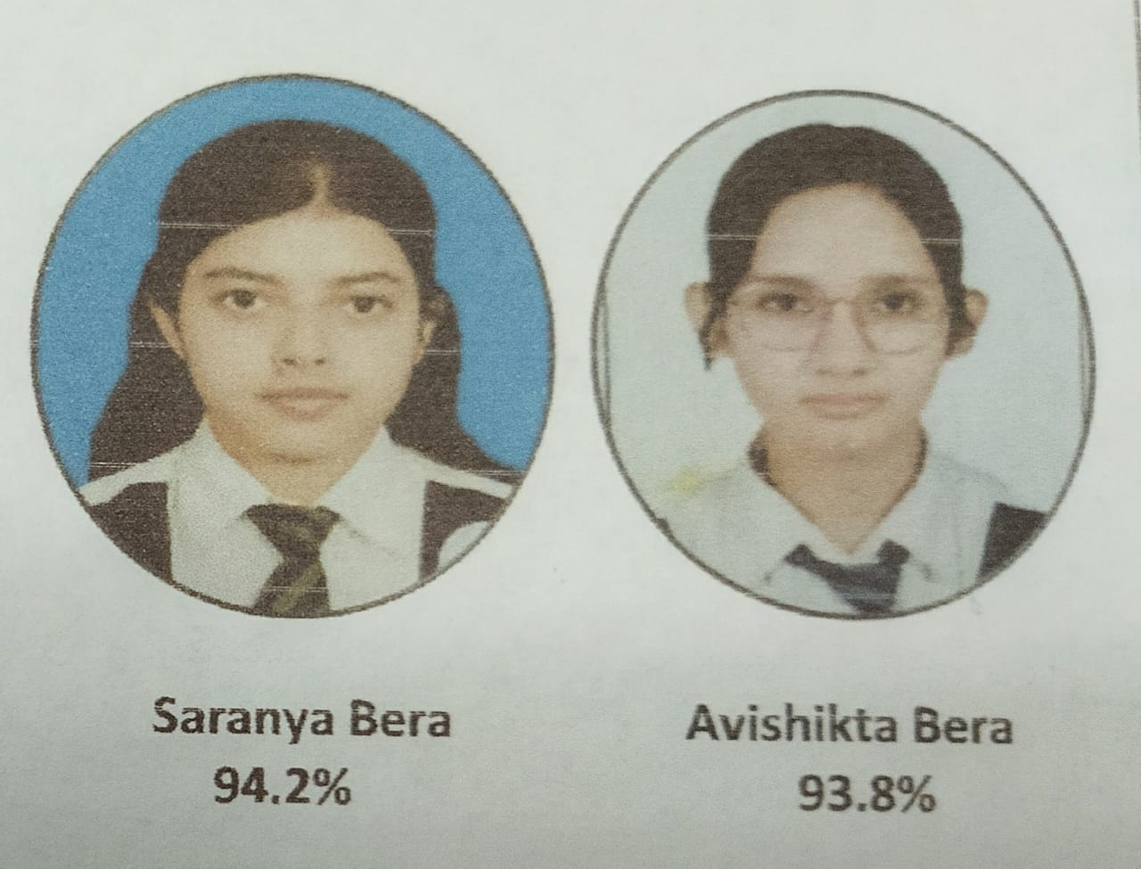

AVISHIKTA BERA
SARANYA BERA

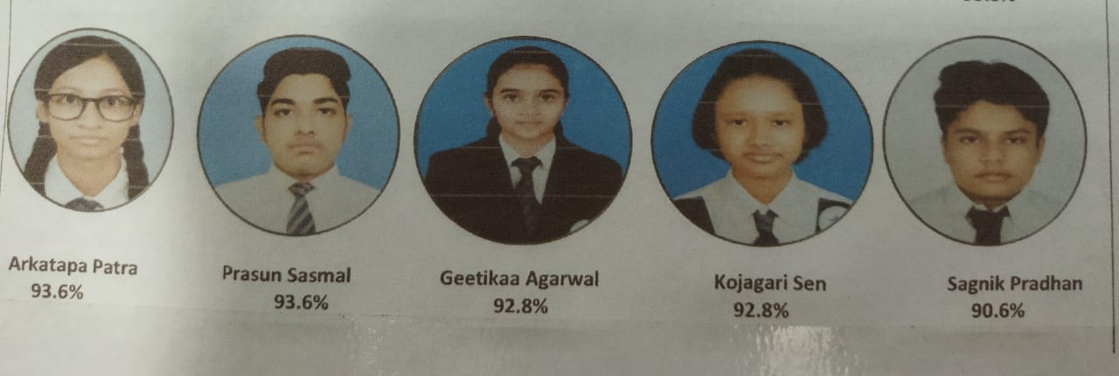

ARKATAPA PATRA, PRASUN SASMAL, GEETIKA AGARWAL, KOJAGORI SEN, SAGNIK PRADHAN

CLASS XII
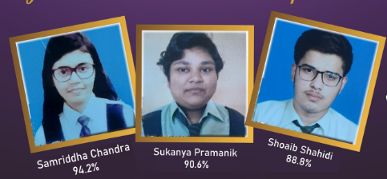

SHOAIB SHAHIDI

SAMRIDDHA CHANDRA

SUKANYA PRAMANIK

GROUND FLOOR
SNO. | PARTICULAR | LENGTH | BREATH | AREA | UNIT | SNO. | PARTICULAR | LENGTH | BREADTH | AREA | UNIT
1 | CLASS ROOM | 24.06 | 19.04 | 458.10 | SFT | 9 | CLASS ROOM | 24.10 | 23.10 | 556.71 | SFT
2 | CLASS ROOM | 24.06 | 19.04 | 458.10 | SFT | 10 | CLASS ROOM | 24.10 | 23.10 | 556.71 | SFT
3 | HOME SCIENCE LAB | 37.06 | 19.04 | 705.62 | SFT | 11 | LIFT1 | 5.06 | 8.10 | 40.99 | SFT
4 | WASHROOM (BOYS) | 15.00 | 12.00 | 180.00 | SFT | 12 | WASHROOM (GIRLS) | 15.00 | 12.00 | 180.00 | SFT
5 | LIFT 2 (PROVISION) | 5.06 | 8.10 | 40.99 | SFT | 13 | WASHROOM (BOYS) | 15.00 | 12.00 | 180.00 | SFT
6 | SPORTS ROOM | 74.00 | 24.00 | 1,776.00 | SFT | 14 | CLASS ROOM | 25.00 | 24.00 | 600.00 | SFT
7 | ACTIVITY ROOM | 37.00 | 23.10 | 854.70 | SFT | 15 | CLASS ROOM | 15.00 | 24.00 | 360.00 | SFT
8 | CLASS ROOM | 24.10 | 23.10 | 556.71 | SFT | 16 | EXAMINATION ROOM | 24.00 | 11.10 | 266.40 | SFT
FIRST FLOOR
SNO. | PARTICULAR | LENGTH | BREATH | AREA | UNIT | SNO. | PARTICULAR | LENGTH | BREADTH | AREA | UNIT
1 | CLASS ROOM | 24.10 | 23.10 | 556.71 | SFT | 10 | CLASS ROOM | 25.00 | 24.00 | 600.00 | SFT
2 | CLASS ROOM | 24.10 | 23.10 | 556.71 | SFT | 11 | CLASS ROOM | 25.00 | 24.00 | 600.00 | SFT
3 | LIBRARY | 37.08 | 24.00 | 889.92 | SFT | 12 | CLASS ROOM | 24.10 | 23.10 | 556.71 | SFT
4 | CLASS ROOM | 24.10 | 23.10 | 556.71 | SFT | 13 | LIFT 1 | 5.06 | 8.10 | 40.99 | SFT
5 | WASHROOM (GIRLS) | 15.00 | 12.00 | 180.00 | SFT | 14 | WASHROOM (GIRLS) | 15.00 | 12.00 | 180.00 | SFT
6 | ART &CRAFT ROOM | 24.06 | 23.10 | 555.79 | SFT | 15 | WASHROOM (BOYS) | 15.00 | 12.00 | 180.00 | SFT
7 | MUSIC ROOM | 24.06 | 23.10 | 555.79 | SFT | 16 | COMPUTER LAB | 37.06 | 19.06 | 706.36 | SFT
8 | DANCE ROOM | 24.06 | 23.10 | 555.79 | SFT | 17 | PHYSIC LAB | 37.06 | 19.06 | 706.36 | SFT
9 | CLASS ROOM | 25.00 | 24.00 | 600.00 | SFT | 18 | STAFF ROOM | 24.00 | 11.10 | 266.40 | SFT

SECOND FLOOR

SNO. | PARTICULAR | LENGTH | BREATH | AREA | UNIT | SNO. | PARTICULAR | LENGTH | BREATH | AREA | UNIT
1 | CLASS ROOM | 24.00 | 19.10 | 458.40 | SFT | 9 | HALL ROOM (Auditorium) | 24.00 | 110.10 | 2,642.40 | SFT
2 | CLASS ROOM | 37.06 | 19.06 | 706.36 | SFT | 10 | LIFT 1 | 5.06 | 8.10 | 40.99 | SFT
3 | CLASS ROOM | 37.06 | 19.06 | 706.36 | SFT | 11 | WASHROOM (GIRLS) | 15.00 | 12.00 | 180.00 | SFT
4 | MATHS LAB | 24.06 | 23.10 | 555.79 | SFT | 12 | WASHROOM (GIRLS) | 15.00 | 12.00 | 180.00 | SFT
5 | WASHROOM (BOYS) | 15.00 | 12.00 | 180.00 | SFT | 13 | CHEMISTRY LAB | 25.00 | 24.00 | 600.00 | SFT
6 | CLASS ROOM | 24.06 | 23.10 | 555.79 | SFT | 14 | BIOLOGY LAB | 25.00 | 24.00 | 600.00 | SFT
7 | CLASS ROOM | 24.06 | 23.10 | 555.79 | SFT | 15 | STAFF ROOM | 24.00 | 11.10 | 266.40 | SFT
8 | CLASS ROOM | 25.00 | 24.00 | 600.00 | SFT

THIRD FLOOR
SNO  . | PARTICULAR | LENGTH | BREATH | AREA | UNIT | SNO. | PARTICULAR | LENGTH | BREATH | AREA | UNIT
1 | CLASS ROOM | 24.00 | 19.10 | 458.40 | SFT | 10 | CLASS ROOM | 37.06 | 19.06 | 706.36 | SFT
2 | CLASS ROOM | 37.06 | 19.06 | 706.36 | SFT | 11 | CLASS ROOM | 37.06 | 19.06 | 706.36 | SFT
3 | CLASS ROOM | 37.06 | 19.06 | 706.36 | SFT | 12 | CLASS ROOM | 24.06 | 23.10 | 555.79 | SFT
4 | PSYCOLOGY LAB | 24.06 | 23.10 | 555.79 | SFT | 13 | LIFT 1 | 5.06 | 8.10 | 40.99 | SFT
5 | WASHROOM (BOYS) | 15.00 | 12.00 | 180.00 | SFT | 14 | WASHROOM (GIRLS) | 15.00 | 12.00 | 180.00 | SFT
6 | CLASS ROOM | 24.06 | 23.10 | 555.79 | SFT | 15 | WASHROOM (GIRLS) | 15.00 | 12.00 | 180.00 | SFT
7 | GEOGRAPHY LAB | 24.06 | 23.10 | 555.79 | SFT | 16 | CHEMISTRY LAB | 25.00 | 24.00 | 600.00 | SFT
8 | CLASS ROOM | 25.00 | 24.00 | 600.00 | SFT | 17 | BIOLOGY LAB | 25.00 | 24.00 | 600.00 | SFT
9 | CLASS ROOM | 24.00 | 19.10 | 458.40 | SFT | 18 | STAFF ROOM | 24.00 | 11.10 | 266.40 | SFT

OFFICE BLOCK
SNO. | PARTICULAR | LENGTH | BREATH | AREA | UNIT | SNO. | PARTICULAR | LENGTH | BREATH | AREA | UNIT
1 | SERVER ROOM | 19.00 | 12.04 | 228.76 | SFT | 8 | RECEPTION | 37.00 | 23.10 | 854.70 | SFT
2 | RM ROOM | 12.06 | 15.00 | 180.90 | SFT | 9 | MEDICAL ROOM | 24.00 | 15.00 | 360.00 | SFT
3 | WASHROOM (GENTS STAFF | 12.00 | 12.00 | 144.00 | SFT | 10 | TRANSPORT ROOM | 15.00 | 12.00 | 180.00 | SFT
4 | WASHROOM (LADIES STAFF) | 12.00 | 12.00 | 144.00 | SFT | 11 | WASHROOM (PARENTS) | 12.00 | 12.00 | 144.00 | SFT
5 | PRINCIPAL'S ROOM | 37.06 | 19.06 | 706.36 | SFT | 12 | CONFERENCE ROOM | 53.00 | 23.10 | 1,224.30 | SFT
6 | EXTRA ROOM | 12.06 | 15.00 | 180.90 | SFT | 13 | ACCOUNT'S ROOM | 20.00 | 12.00 | 240.00 | SFT
7 | FEES COUNTER | 12.06 | 15.00 | 180.90 | SFT | 14 | CHAIRMAN'S ROOM | 24.00 | 23.10 | 554.40 | SFT

Sl.no. | Room | Number | Length | Breadth | Sl.No | Room | Number | Length | Breadth
1 | Class Room | 26 | 37.06 | 23.10 | 7 | Library | 1 | 37.08 | 24.00
2 | Physics Lab | 1 | 37.06 | 19.06 | 8 | Other Room | 20 | 37.06 | 23.10
3 | Chemistry Lab | 1 | 25.00 | 24.00 | 9 | Geography Lab | 1 | 37.06 | 23.10
4 | Biology Lab | 1 | 25.00 | 24.00 | 10 | Psychology Lab | 1 | 37.06 | 23.10
5 | Math Lab | 1 | 24.06 | 23.10 | 11 | Vacant Class Room | 6 | 37.06 | 23.10
6 | Home Science Lab | 1 | 37.06 | 19.04

Mount Litera Zee School, Contai is of 12158.340 square meter of 3.0033 Acre. Secondly the built up area is 6375.55 square meter. Thirdly the area of the plot on which the school building exists is 1707.44 square meter .Finally the size of the playground id 3962 Square meter
DETAILS OF PLAY GROUND
One Cricket cum Football ground
Dimension: 42 mt. by 24 mt.
One Badminton Court
Dimension: 44 feet by 20 feet
One Volley-Ball Court
Dimension: 80 feet by 45 feet
Swimming Pool
Gymnasium

The school is grateful to our trustee, PASUPATI TRUST MEMORIAL, who has been ensuring the rapid acceleration in the growth of our school by providing us support to create an enviable campus infrastructure and by employing competent manpower.
Last but not the least, the unfailing devotion and diligence of the teachers and administrative staff who have made this a rewarding year for the whole community needs to be acknowledged to a great extent. I owe to them; Our teachers are fully dedicated to their task and do their best for the students. They spent extra hours to prepare the students for all activities so that they realize their highest potential. I express my gratitude to them

Mount Litera Zee School, Contai is of 12158.340 square meter of 3.0033 Acre. Secondly the built up area is 6375.55 square meter. Thirdly the area of the plot on which the school building exists is 1707.44 square meter .Finally the size of the playground id 3962 Square meter
DETAILS OF PLAY GROUND
One Cricket cum Football ground
Dimension: 42 mt. by 24 mt.
One Badminton Court
Dimension: 44 feet by 20 feet
One Volley-Ball Court
Dimension: 80 feet by 45 feet
Swimming Pool
Gymnasium

Mount Litera Zee School, Contai is of 12158.340 square meter of 3.0033 Acre. Secondly the built up area is 6375.55 square meter. Thirdly the area of the plot on which the school building exists is 1707.44 square meter .Finally the size of the playground id 3962 Square meter
DETAILS OF PLAY GROUND
One Cricket cum Football ground
Dimension: 42 mt. by 24 mt.
One Badminton Court
Dimension: 44 feet by 20 feet
One Volley-Ball Court
Dimension: 80 feet by 45 feet
Swimming Pool
Gymnasium

Academic Calendar (Session 2021-22 Examination Schedule)
MOUNT LITERA ZEE SCHOOL, CONTAI
SESSION – 2022-23 EXAMINATION SCHEDULE
(THESE DATES MAY CHANGE AS PER THE CBSE GUIDELINES)
FOR GRADE – I &II
PT 1(I, II)
DATE | CLASS I | CLASS II
11.07.22 | ENGLISH | MATHEMATICS
12.07.22 | GK | COMPUTER
13.07.22 | EVS | SECOND LANGUAGE
14.07.22 | COMPUTER | GK
15.07.22 | SECOND LANGUAGE | EVS
18.07.22 | MATHEMATICS | ENGLISH
PT 2(I, II)

DATE | CLASS I | CLASS II
22.09.22 | MATHEMATICS | ENGLISH
23.09.22 | COMPUTER | GK
26.09.22 | GK | EVS
27.09.22 | EVS | SECOND LANGUAGE
28.09.22 | ENGLISH | MATHEMATICS
29.09.22 | SECOND LANGUAGE | COMPUTER

PT 3(I,II)
DATE | CLASS I | CLASS II
09.01.23 | MATHEMATICS | ENGLISH
10.01.23 | COMPUTER | GK
11.01.23 | GK | EVS
13.01.23 | EVS | SECOND LANGUAGE
16.01.23 | ENGLISH | MATHEMATICS
17.01.23 | SECOND LANGUAGE | COMPUTER

PT 4(I, II)

DATE | CLASS I | CLASS II
01.03.23 | ENGLISH | MATHEMATICS
02.03.23 | EVS | COMPUTER
03.03.23 | COMPUTER | EVS
06.03.23 | SECOND LANGUAGE | ENGLISH
07.03.23 | MATHEMATICS | GK
08.03.23 | GK | SECOND LANGUAGE

SESSION – 2022-23 EXAMINATION SCHEDULE
(THESE DATES MAY CHANGE AS PER THE CBSE GUIDELINES)
FOR GRADE – III-VIII
PT1 (III-VIII)
DATE | CLASS III |  | CLASS IV | CLASS V | CLASS VI | CLASS VII | CLASS VIII
11.07.22 | EVS |  | MATHS | ENGLISH | SOCIAL SCIENCE | MATHS | SOCIAL SCIENCE
12.07.22 | 2ND LANG |  | COMP | EVS | 2ND LANG | COMPUTER | 2ND LANG
13.07.22 | COMPUTER |  | EVS | 2ND LANG | ENGLISH | SCIENCE | ENGLISH
14.07.22 | ENGLISH |  | 2ND LANG | COMPUTER | COMPUTER | 2ND LANG | COMPUTER
15.07.22 | GK |  | GK | GK | SCIENCE | ENGLISH | SCIENCE
18.07.22 | MATHS | ENGLISH |  | MATHS | 3RD LANG | 3RD LANG | 3RD LANG
19.07.22 |  |  |  |  | MATHS | SOCIAL SCIENCE | MATHS
HY (III-VIII)
DATE | CLASS III | CLASS IV | CLASS V | CLASS VI | CLASS VII | CLASS VIII
22.09.22 | MATHS | ENGLISH | MATHS | MATHS | SOCIAL SCIENCE | MATHS
23.09.22 | EVS | EVS | COMP | COMPUTER | 2ND LANG | 2ND LANG
26.09.22 | COMPUTER | 2ND LANG | EVS | ENGLISH | SCIENCE | SOCIAL SCIENCE
27.09.22 | ENGLISH | COMPUTER | 2ND LANG | 2ND LANG | COMPUTER | COMPUTER
28.09.22 | 2ND LANG | MATHS | ENGLISH | SCIENCE | ENGLISH | SCIENCE
29.09.22 | GK | GK | GK | 3RD LANG | MATHS | 3RD LANG
30.09.22 |  |  |  | SOCIAL SCIENCE | 3RD LANG | ENGLISH

PT 2 (III-VIII)
DATE | CLASS III | CLASS IV | CLASS V | CLASS VI | CLASS VII | CLASS VIII
09.01.23 | ENGLISH | MATHS | MATHS | SOCIAL SCIENCE | MATHS | SOCIAL SCIENCE
10.01.23 | EVS | EVS | COMP | 2ND LANG | COMPUTER | 2ND LANG
11.01.23 | 2ND LANG | COMPUTER | ENGLISH | ENGLISH | ENGLISH | SCIENCE
13.01.23 | COMPUTER | ENGLISH | 2ND LANG | MATHS | SOCIAL SCIENCE | MATHS
16.01.23 | MATHS | 2ND LANG | EVS | SCIENCE | SCIENCE | ENGLISH
17.01.23 | GK | GK | GK | COMPUTER | 2ND LANG | COMPUTER
18.01.23 |  |  |  | 3RD LANG | 3RD LANG | 3RD LANG

YEARLY (III-VIII)
DATE | CLASS III |  | CLASS IV | CLASS V | CLASS VI | CLASS VII | CLASS VIII
01.03.23 | MATHS |  | ENGLISH | EVS | MATHS | SOCIAL SCIENCE | ENGLISH
02.03.23 | COMP |  | COMPUTER | MATHS | COMPUTER | COMPUTER | 2ND LANG
03.03.23 | EVS |  | 2ND LANG | COMPUTER | ENGLISH | SCIENCE | COMPUTER
06.03.23 | ENGLISH |  | MATHS | ENGLISH | SOCIAL SCIENCE | MATHS | MATHS
07.03.23 | 2ND LANG |  | EVS | 2ND LANG | SCIENCE | ENGLISH | SCIENCE
08.03.23 | GK | GK |  | GK | 3RD LANG | 3RD LANG | 3RD LANG
09.03.23 |  |  |  |  | 2ND LANG | 2ND LANG | SOCIAL SCIENCE
SESSION – 2022-23 EXAMINATION SCHEDULE
(THESE DATES MAY CHANGE AS PER THE CBSE GUIDELINES)
FOR GRADE – IX
PT- 1
DATE | CLASS IX
11.07.22 | SOCIAL SCIENCE
12.07.22 | 2ND LANG
13.07.22 | ENGLISH
14.07.22 | IT
15.07.22 | SCIENCE
18.07.22 | MATHS

PT- 2

DATE | CLASS IX
22.09.22 | SOCIAL SCIENCE
23.09.22 | IT
26.09.22 | MATHS
27.09.22 | 2ND LANG
28.09.22 | ENGLISH
30.09.22 | SCIENCE

PT- 3

DATE | CLASS IX
09.01.23 | MATHS
10.01.23 | 2ND LANG
11.01.23 | ENGLISH
13.01.23 | SCIENCE
16.01.23 | SOCIAL SCIENCE
17.01.23 | IT

YEARLY EXAMINATION

DATE | CLASS IX
01.03.23 | SOCIAL SCIENCE
02.03.23 | 2ND LANG
03.03.23 | ENGLISH
06.03.23 | MATHS
07.03.23 | IT
08.03.23 | SCIENCE

SESSION – 2022-23 EXAMINATION SCHEDULE
(THESE DATES MAY CHANGE AS PER THE CBSE GUIDELINES)
FOR GRADE – X
PT- 1
DATE | CLASS X
11.07.22 | MATHS
12.07.22 | ENGLISH
13.07.22 | 2ND LANG
14.07.22 | IT
15.07.22 | SCIENCE
18.07.22 | SOCIAL SCIENCE
PT- 2

DATE | CLASS X
22.09.22 | SOCIAL SCIENCE
23.09.22 | 2ND LANG
26.09.22 | MATHS
27.10.22 | IT
28.10.22 | SCIENCE
29.10.22 | ENGLISH
PT- 3

DATE | CLASS X
19.01.23 | MATHS
20.01.23 | 2ND LANG
24.01.23 | SOCIAL SCIENCE
25.01.23 | ENGLISH
27.01.23 | SCIENCE
30.01.23 | IT
- Pre board exam schedule of grade X depends on the schedule of board exam.

GRADE XI
EXAMINATION SCHEDULE

UT 1 DATE | HY DATE | UT 2 DATE | FINAL EXAM DATE | SUBJECTS
11.07.22 | 22.09.22 | 19.01.23 | 01.03.23 | PHY/ACCT/POL.SC
12.07.22 | 23.09.22 | 20.01.23 | 02.03.23 | BENGALI/PHY.EDU/HINDI/IT/COM.SC
13.07.22 | 26.09.22 | 24.01.23 | 03.03.23 | CHEMISTRY/GEOGRAPHY/PSYCHOLOGY
14.07.22 | 27.09.22 | 25.01.23 | 06.03.23 | BIO/EARLY CHILDHOOD/HOME.SC/HISTORY
15.07.22 | 28.09.22 | 27.01.23 | 07.03.23 | ENGLISH
18.07.22 | 29.09.22 | 30.01.23 | 08.03.23 | MATH
19.07.22 | 30.09.22 | 31.01.23 | 09.03.23 | YOGA/FOOD NU &DI/ECONOMICS

GRADE XII
EXAMINATION SCHEDULE

UNIT 1 EXAMINATION DATE | HALF YEARLY EXAMINATION  DATE | PREBOARD EXAMINATION | SUBJECTS
11.07.22 | 22.09.22 | 19.01.23 | PHY/ACCT/POL.SC
12.07.22 | 23.09.22 | 20.01.23 | BENGALI/PHY.EDU/HINDI/IT/COM.SC
13.07.22 | 26.09.22 | 24.01.23 | CHEMISTRY/GEOGRAPHY/PSYCHOLOGY
14.07.22 | 27.09.22 | 25.01.23 | BIO/EARLY CHILDHOOD/HOME.SC/HISTORY
15.07.22 | 28.09.22 | 27.01.23 | ENGLISH
18.07.22 | 29.09.22 | 30.01.23 | MATH
19.07.22 | 30.09.22 | 31.01.23 | YOGA/FOOD NU &DI/ECONOMICS

- Pre board exam schedule of grade XII depends on the schedule of board exam.

- DATES OF EXAM ARE SUBJECTED TO CHANGE AS PER CBSE GUIDELINES AND COVID GUIDELINES AND CENTRAL/STATE NORMS.

IT MAY KINDLY BE NOTED THAT THE HALFYEARLY, UNIT 2 AND YEARLY EXAM OF STD XI WILL BE CONDUCTED IN THE SAME WINDOW PERIOD OF STD X. DATES OF EXAM ARE SUBJECTED TO CHANGE AS PER CBSE GUIDELINES AND COVID GUIDELINES AND CENTRAL/STATE NORMS.

EFFORTS MADE ON ENVIRONMENT EDUCATION
CBSE has given their main focus on Different Social Empowerment through Work and Environmental issues. The board has also taken various initiatives to sensitize schools and the students to emergent environmental concerns like Greening of campus, environmental conservation, cleanliness, One child one plant campaign etc. As per this circular ECO -CLUB of our school of MOUNT LITERA ZEE SCHOOL CONTAI, has already taken initiatives to Conserve the environment by various means:
Dignity of labour Activity:( DATE: 2.7.22):
Video shown on blue collar and white collar job

Empathy: Poster Making Activity on Environment conscious Citizens:
Animals are our Friends ( DATE: 16.8.22)
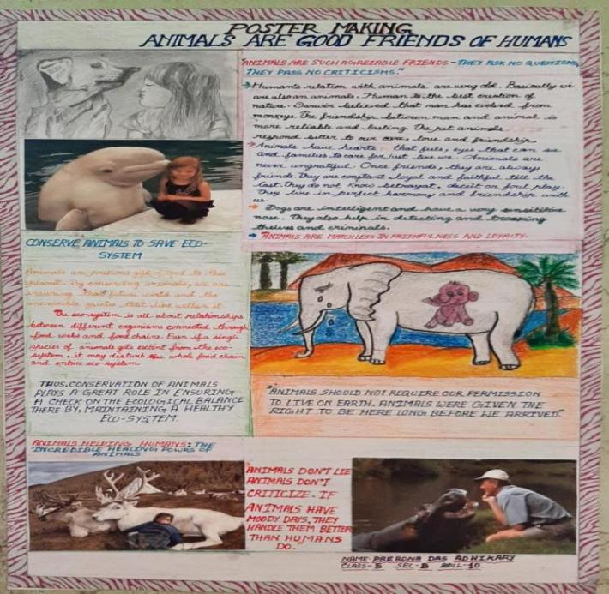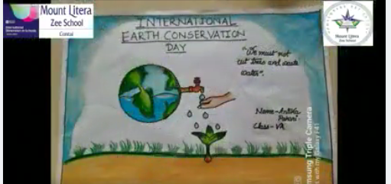

Environment conscious Citizens:World Environment Day Observation( DATE:22.4.22)
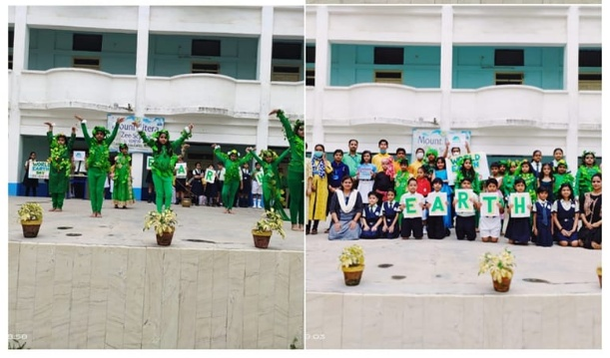
#International_Earth Day #2K22 #live_a_more_sustainable_life
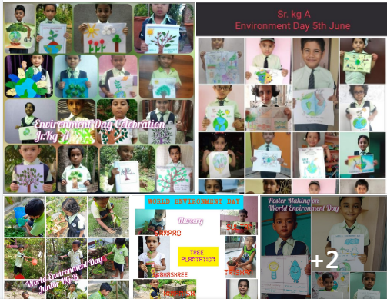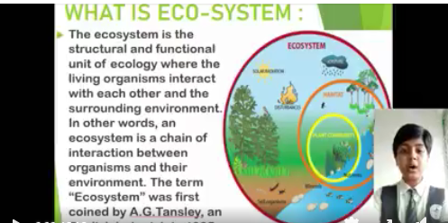
Reduce, Reuse and Recycle Vanmahotsav and plastic bag free day:( DATE:3.7.22)

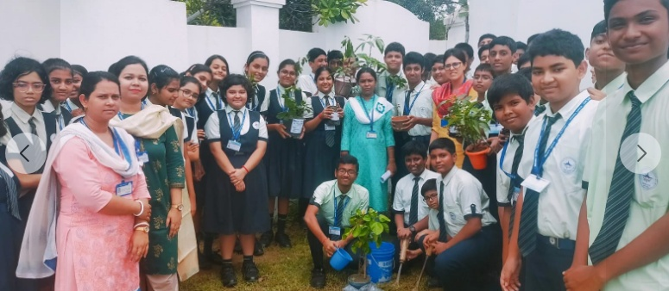
#Cut_the_greed_not_the_trees #Van_Mahotsav_2022

Studying Health Status in a Peer Group/ Community: Skit presentation on diseases : (DATE: 6.12.22)
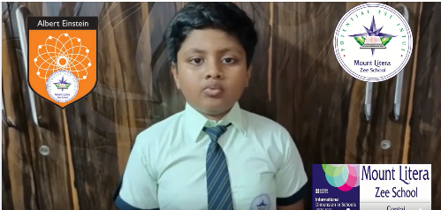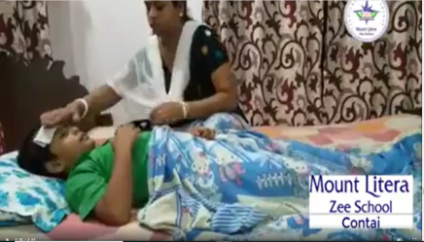

Plantation of the tree: Vertical Gardening done by class 9(Date:11.12.22)
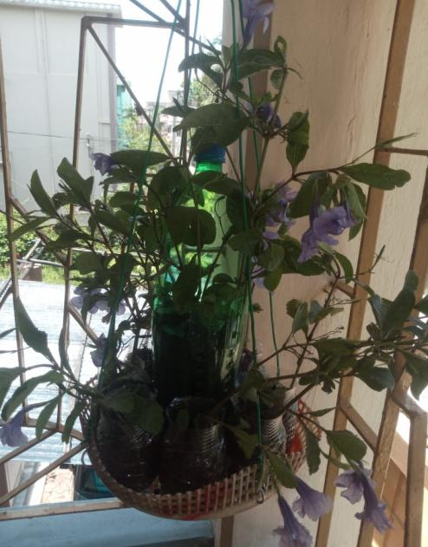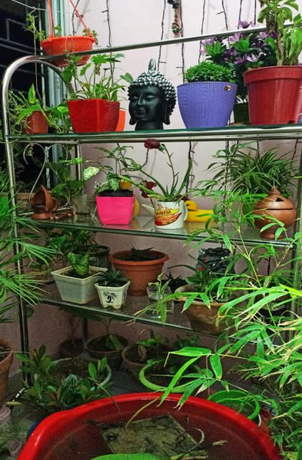
Family Budget And Daily House Resources of class room and school Accounts(Date:16.12.22) (Date:20.2.22)

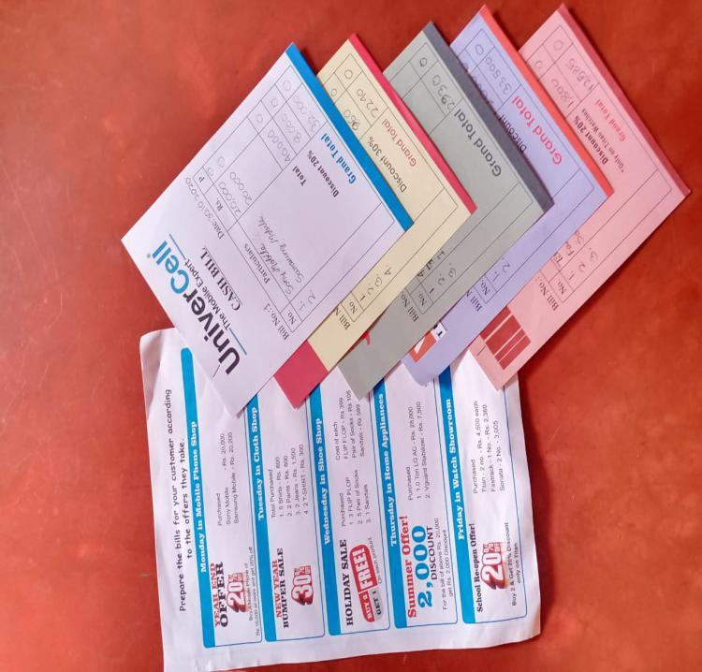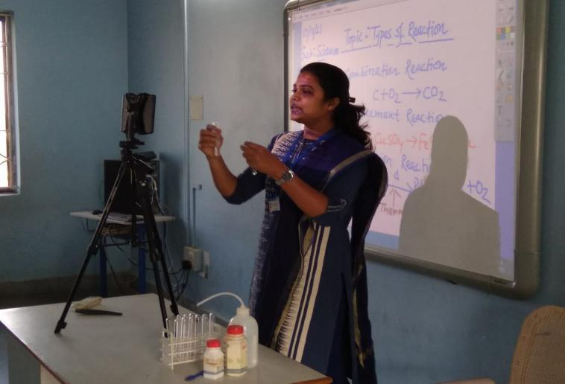
Empathy:(Date:20.12.22) Saving One Litre Water per day (5.11.22)
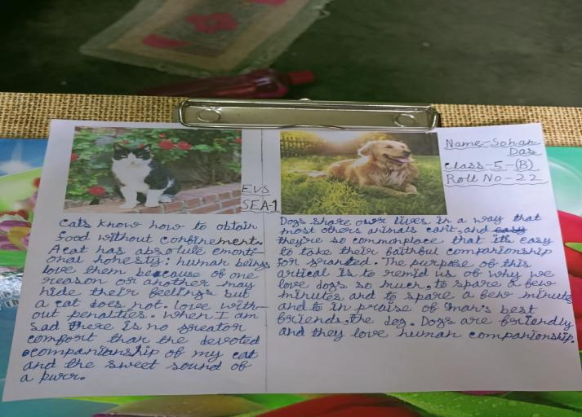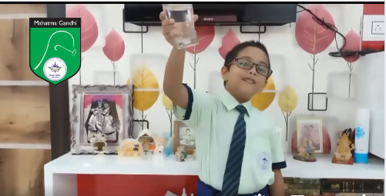
Project on Social Awareness initiated by the teacher:(5.6.22)
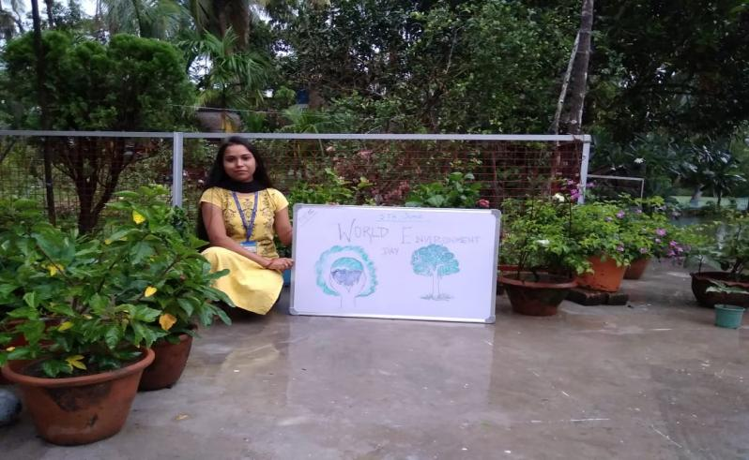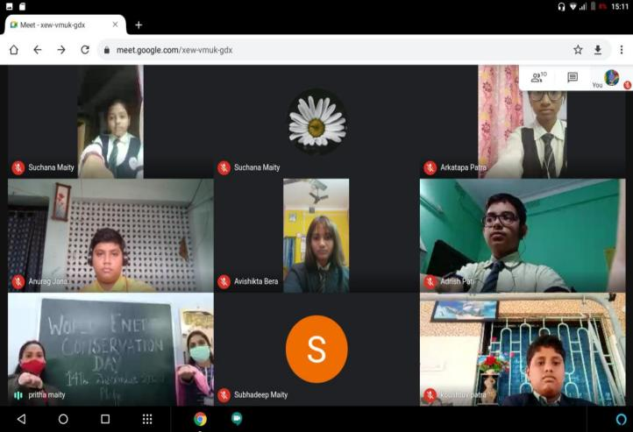
Life Skill Activities:(Date:12.11.22)
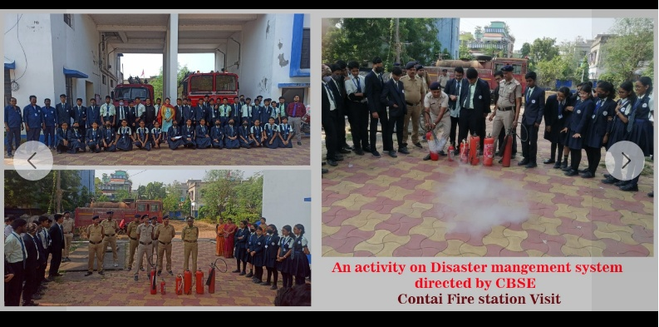
In School activity of science teachers( Pledge on Energy Conservation)(Date:14.12.22)
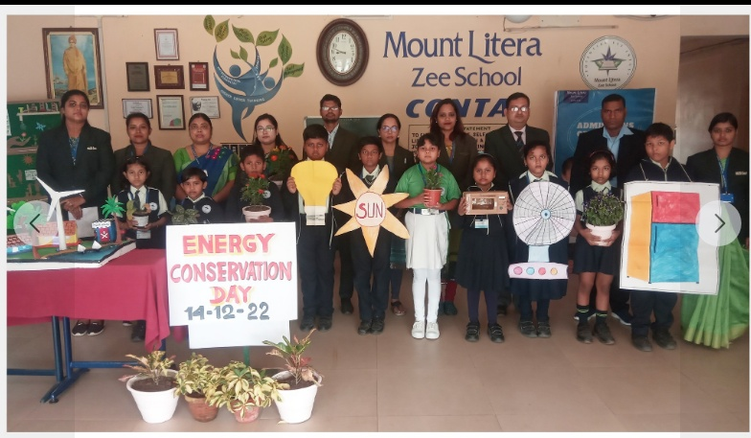
#Use_energy_judiciously #keep_in_mind_the_needs_of_the_future
Volunteer Work with stray Animals:(Date:20.12.22)
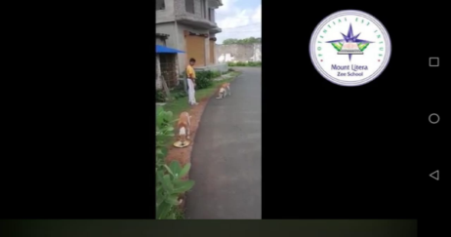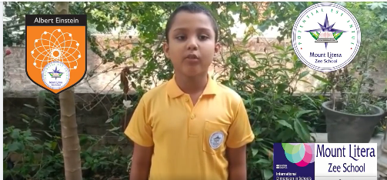
Home water use (Audit):( Date: 4.11.22)
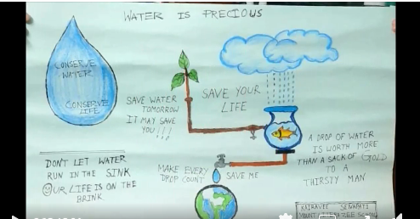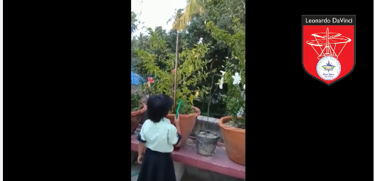
Indigenous project of water conservation:(Date:12.8.22)
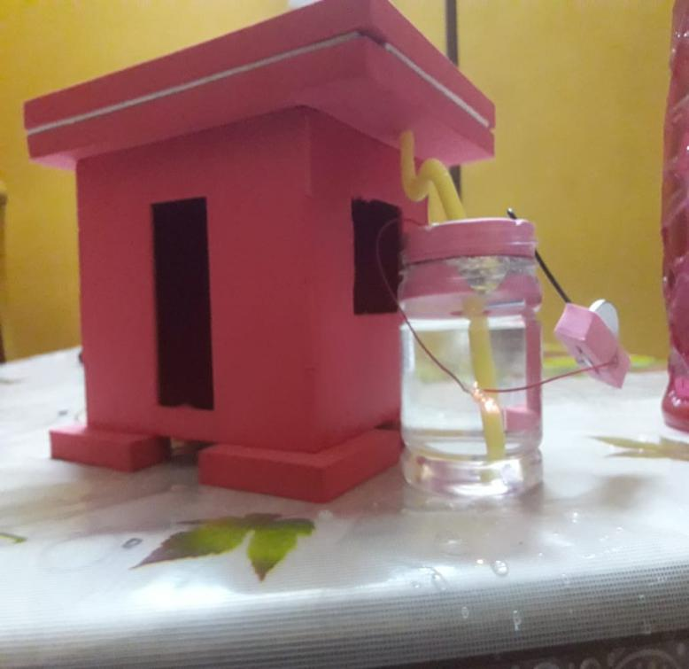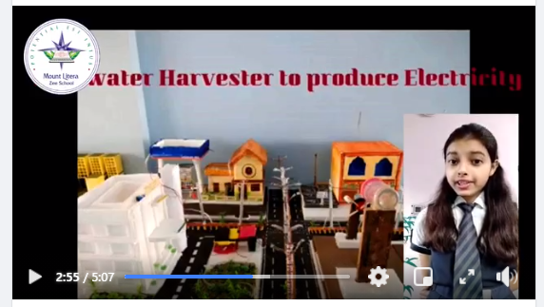
Projects of recycling of water from RO Plants:(Date:3.9.22)
Setting up modern irrigation technique in school/ home garden:(Date:12.9.22)
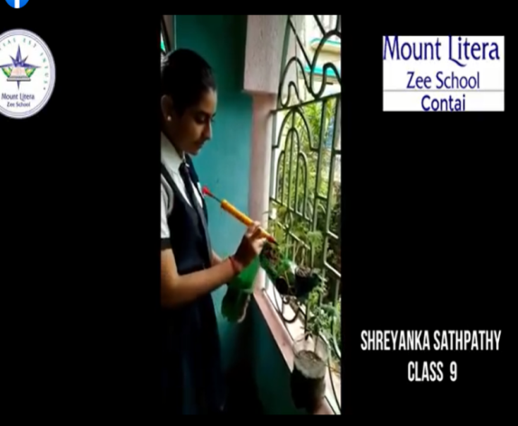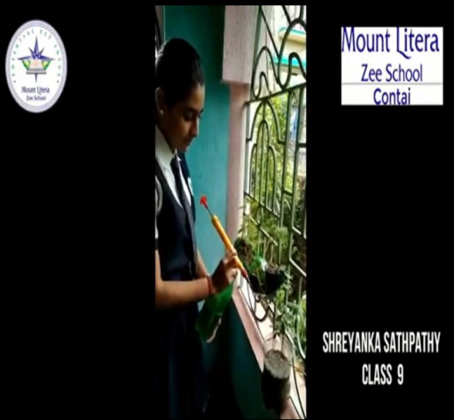

Details of Teachers including Qualification
No. | NAME | DESIGNATION | QUALIFICATION
1 | Dr.Yogesh Maheswari | Principal | CBSE AWARDEE(2018-2019) D-Litt, PDF - ICSSR, New Delhi Ph. D. M.Com, MBA (Mkt & Fin), MBM (Banking),MA(Edu), M.Ed
2 | Satabdi Panigrahi | School Counselor and Acting coordinator of Pre Primary & Primary | M.A. (Psychology) & M.A. (Geography), DE-LED. B-ED
3 | Pritha Maity | Co-Ordinator (IX-XII) | M.Sc(Bio Informatics), B.Ed, STET,CTET,PTET,PDPET
4 | Sayantan Ghorai | Co-Ordinator (VI-VIII) | M.Sc(PHYSICS), B.Ed, STET
5 | Rimu Roy | Co-Ordinator (Nur – IV) | M.A(Eng), B.Ed, Primary TET , PDPET , PTE
6 | Falguni Chakraborty | International coordinator Assistant Teacher | M.A(Geography), B.Ed, CTET
7 | Asit Kumar Das | Assistant Teacher | M.Sc. (Physics), B.Ed, CTET
8 | Bidisa Shee | Librarian | B.A, B.Lib
9 | Indrani Kar | Special Educator | M.A(ENG), B.A(ENG), SPL.D.Ed,
10 | Shampa Kundu | PTI | B.A. ,B.P.Ed
11 | Chandana Kapilas | Assistant Teacher | M.A(Dance) MSW
12 | Animesh Naskar | Assistant Teacher | BFA, MFA(Gold Medalist)
13 | Debanjan Panda | Assistant Teacher (GUITAR) | M.A (ENG)  DIPLOMA (GUITAR)
14 | Sudhanshu Jana | Assistant Teacher (VIOLIN) | BA DIPLOMA (VIOLIN)
15 | Debapriya Basu | Assistant Teacher | MCA,B. Ed
16 | Abhijeet Dutta | Assistant Teacher | M.A(Eng), B.Ed, CTET, STET
17 | Niru Kumari Singh | Assistant Teacher | M.A(HIND), B.Ed
18 | Subhankar Biswas | Assistant Teacher | M.A(HINDI), B.Ed
19 | Nabanita Pandey Maity | Assistant Teacher | M.A. (Bengali), B.Ed, STET
20 | Suman Anand | Assistant Teacher | B.Com, MA (ENVS STUDIES) NTT, D.EL.ED, B.ED
21 | Atanu Ghorai | Assistant Teacher | B.P. Ed
22 | Sarmistha Das | Assistant Teacher | M.A. (Bengali) ,B.Ed, TET
23 | Sujata Das Mahapatra | Assistant Teacher | B.Com, NTT , B.ED , MA. (ECONOMICS)
24 | Soma Maity | Assistant Teacher | M.A. (Music). D.EL.ED
25 | Rituparna Majumdar | Assistant Librarian | M.Sc. (Home Science), B. Lib.
26 | Sangeeta jana | Assistant Teacher | M.A(ENG), B.A(ENG),B Ed, PDPET

27 | Santanu Sanyal | Assistant Teacher | M.Com, ICWAI(I), ICAI(I), B.ED,
28 | Panchali Maity | Assistant Teacher | MA (ENGLISH-SILUER MEDALIST)  BA (ENGLISH-SILUER MEDALIST)  B.ED. TET,UPPER PRIMARY
29 | Surajit Das | Assistant Teacher | MSC (MATHEMATICS), B.ED
30 | Megha Pradhan | Assistant Teacher | M.A (ENG), B.Ed
31 | DebaPrasad Chakraborty | Assistant Teacher | M.A(History). B.ED
32 | Debojyoti Mukherjee | Assistant Teacher | M.A (Math), B.Ed. STET
33 | Buddhadev Rana | Assistant Teacher | MFA
34 | Atanu Das | Assistant Teacher | MCA (Comp), B.ED
35 | Sova Maishal | Assistant Teacher | Double M.A (Bengali) B.Ed.
36 | Tasmeen Hussain | Assistant Teacher | M.Sc (Botany) B.Ed
37 | Anindita Maity | Assistant Teacher | M.A (Beng), B.Ed  CTET, STET, Pry TET,
38 | Ajay Nandi | Karate Judo Teacher  National Coach (JUDO) | B.A DIPLOMA IN JUDO
39 | Sukumar Pradhan | Assistant Teacher (YOGA) | B.SC(BIO), BTET, DIPLOMA IN YOGA
40 | Alakananda De | Assistant Teacher | M.SC (PHYSIOLOGY), D.EL.ED
41 | Mohon Tripathi | Assistant Teacher | MSC(MATH), M.C.A,  B.ED, STET
42 | Debarati Maity | Assistant Teacher | MSC(Home Sc),  B.ED
43 | Moumita Das | Assistant Teacher | M Sc (Chem) B.Ed
44 | Autunu Ghoroi | Assistant Teacher | BA MPEd
45 | Sangeeta Bera Manna | Assistant Teacher | MA (Sanskrit) B.Ed

DETAILS OF TEACHERS TRAINING

Zee trainings:-

- Suman Anand attended a session on importance of Clubs in school hosted by Mr Bhusan Kuamar and RSD Dibeyendu Sharma on 17.7.22.
- Subhankar Biswas attended a session on 3.7.22 on the topic of Prevention of Bullying in school.
- Indrani Kar attended the following training:-
- Teaching skills, tools and platforms. (08.06.2022)
2. Growth mindset (11.06.22)
3. Intervention strategies for primary classes (17.06.22)
4. Nurturing explores (03.07.2022)

- Soma Khatun:
1.Topic – Enhancing school admission(28.11.2022) From- zee learn
By – Dr. Prabhat kaushik
2.Topic – Transform school series (5.12.2022) From – zee learn
By- Dr. Prabhat kaushik
- Debapriya Basu:-
Online SEA teachers training organized by zee learn limited (16.07.2022)
- Abhijeet Dutta:-
- SEA implementation
- Teaching of Poetry by RSD.
- Amrita Maity attended training on SEA imparted by ZEE learn on 13th July 2022.
- Abid Ansari
1. Intergration of Art's in scholastic subject (28/6/21) from zee learn 2. Teaching skill in Hindi (29/6/22) from zee learn
- Manisha Maity attended following trainings
1.06.22 E learning (Zee)
17.06.22 Happy classroom. (Zee)
13.07.22 Sea 1. English ( Zee)
06.07.22 Teaching as a carrier.(Zee)
11.07.22 Learning Challenges.(Zee)
17.07.22 Skills for answering a question in the classroom (Zee)
18 .07.22 Clubs of school.( Zee)
- Sangita Jana Patra
1. E learning by Zee (02.6.22)
2. Blended Learning by PAN India (17.6.22)
3. SEA1 English by Zee (13.7.22)
4.Skills for answering a question in the classroom by zee (17.7.22)
5.Clubs of school by Zee (18.7.22)
- Anindita Dash
1.E learning by Zee (10.6.22)
2.Blended Learning by PAN India (17.6.22)
3.Learning Challenges by other (11.7.22)
4.SEA1 English by Zee (13.7.22)
5.Skills for answering a question in the classroom by zee(17.7.22)

CBSE Trainings:-

- Subhanar Biswas had undergone five trainings imparted by CBSE on following topics:-
1. Hindi Bhasa me likhon tatha Sahitya Srijan
2. Innovative and creative teaching in Hindi
3. Teaching strategies in Hindi for Secondary Level
4. Hindi lesson planning on special emphasis on art-integration, competency, real life connectivity.
5. Online panel discussion on NEP2020 implementation and challenges
6. Bloom's taxonomy and its application
7. Salient feature of national education policy 2020
8. CBSE Hindi term 2 dialogues with the expert
innovative teaching of Hindi languages for primary classes
easy way to make effective MCQs in Hindi
दसवीं कक्षा के व्याकरण व पाठ्यपुस्तक खंड की स्तरीय तैयारी एवं अभ्यास की सरल युक्तियाँ creative writing, reading, comprehension and other language activities in Hindi

- Niru Singh attended the following training:-
1. Hindi Vishay ke Prati Kaise karvayen chhatron ka ruk jao (19/4/22)
2. Hindi bhasha mein lekhan tatha Sahitya Srijan (29/6/22)
3. Sansodhit Bloom vyakarnik per aadharit vishisht uddesh Hindi (17/7/22)
4. Free online training program storytelling as pedology in Hindi (15/6/22) CBSE Bharat Sahodaya
5. Vyakarnik chunautiyan (5/6/22)
6. - दसवीं कक्षा के व्याकरण (16.10.22) (CBSE Bharat Sahodaya)
7.Experimental Learning Course ( Diksha portal ) 19.11.22
8. Artificial intelligence (CBSE Bharat Sahodaya) 21.12.22
- Tasmin Hussain attended the following trainings:
1.Effective Communication Skills on 27.5.22
2.Art Integration In Biology and Competency based teaching 24.7.22

- Pritam Roy had undergone the following trainings:-
1. Panel Discussion-NEP 2020 Implementation and Challenges 13.6.22
2. Awareness Program for School Teachers on Innovation Ambassador Training Program, Hackathons, Atal Academy and Student Induction Program 14.6.22
3.Promoting Mental Health (Webex) 15.6.22
4."School Innovation Ambassador Training Program" for School Teachers 16.6.22
- Debapriya Basu:-
1.Online session on Essential Components of a Lesson Plan by CBSE 28.5.22 :
2.online session on Cyber security and Ethics by CBSE 31.05.2022
3.Setting learning Outcomes in Teaching and Learning, by CBSE12.06.2022
4.Teaching and learning style by CBSE 18.06.2022
5.Live webinar on the various initiatives, Innovation Ambassador Program by CBSE 14.06.2022
6.First module on “Design Thinking and Innovation” under school ambassador training program by CBSE 03-08-22 To 16-08-22
7. Employability Skills by CBSE 28.10.22
8.Accessibility and Special Education conducted by CBSE in
partnership with Microsoft. 11.11.22
9.Term1 evaluation system by CBSE 13.11.22

- Abhijeet Dutta:-
- Artificial Intelligence application on English.
- Teaching English in Secondary Curriculum

- Surajit Das attended following trainings
- Revised assessment structure for class IX and X.(CBSE)
- AI Integrated Multi- Disciplinary Pedagogies for math (21 to 23 June 2022)(CBSE)
- National Webinar on Booming careers in science in the post Covid era (11 July 2022)
- CBSE career guidance and counseling Webinar of school students
- 8. NEP 2020(18 July 2022) by CBSE

- Abid Ansari attended the following trainings

- Teaching strategies in Hindi (17/8/22) from CBSE
- Hindi Bhasha me lekhan tatha(23/8/22) from CBSE

- Megha Pradhan attended the following trainings

1. Experiential learning (CBSE)
2. Competency based learning- module 1(CBSE)
3. Competency based learning- module 2
(CBSE)
4. How to create Language learning content (CBSE)

- Soma Khatun attended training on Graphic Novels for effective learning on 23.8.22.

- Moumita Das attended the following trainings on

1. Integrated -Multi Disciplinary pedagogies. (CBSE)
Date: 24 th June to 26 th June.

2. Course name: Young Warrior movement against Covid 19.(CBSE)
Date: 6 June to 9 th June.

3. Course name: Innovative Ambassador Training. (GOING ON )
Only 2 module has completed till date.(CBSE).

- Dr Yogesh Maheswari attended the following CBSE trainings:-

- Value Education on 27.7.22
- Teaching strategies for Autistic children on 22.7.22
- AI on Multi Disciplinary 8.6.22
- Young Warriors on 11.6.22
- Promoting Mental Health on 25.8.22
- Adopting Inclusive Practices in Classroom on 21.6.22
- Values Education and its Significance
- Stress Management Techniques
- Story telling Pedagogy
- Understanding Multiple Intelligence on 20.7.22
- Adopting Inclusive Practices in Classroom

Others agency:-

- Subhankar Biswas attended training by Madhuban Publication on Teaching of Hindi on 19.6.22.
- Niru Singh attended the following training:-

Full marks Publication
6. Vyakaran vyapak drishtikon shrinkhala (14/7/22)
7. Shabd pad pad band AVN pad bandhuon ke Bhed (21/7/22)
8. Vakya ke Ang tatha Vakya Bhed (28/7/23)
9. Pad band tatha upvakya upvakya ke Bhed (4/8/22)
10. Phonics sound (8/8/22)
11. Kriya- Kriya pad band ki Rachna tatha Kriya Bhed provide (11/8/22)
12. Sword India NEP (13/6/22)
*Madhuban Publication
13. Hindi language teaching (23/6/22)
14. Loyola Degree College Bangalore
* Aadivasi janjati & nari sashaktikaran(7/8/21)
* Rashtriy Bhasha Seva Sangh Hyderabad
15. Online worksheet (3/6/22)
16. Class click 17/5/22
17. Online certificate 29/5/22

- Training by Indrani Kar:
1. Positive screen time-television VS reading eggs (22.05.2022)
2. Preschool for E-learning (01.06.2021)
3. Learners with special needs: with reading eggs-based on NEP (05.06.2022)

- By Debapriya Basu:-

1. 16.04.2022: webinar on office 365 apps organized by Microsoft
2. Date: 22.05.2022: Webinar on Positive Screen Time,Television Vs Reading Eggs organized by Ratna sagar

3. Date: 21.05.2022 : Webinar on effective computer teaching and scratch programming organized by Orange education Pvt.Ltd.
4. Date: 08.08.22: Advance excel training by BIZWIZ.CO.IN
5. Date: 12.8.22: Introduction to Pat Cognos Learning Platform.

- By Abhijeet Dutta:-
- National Webinar on Quality Education, Accreditation and Teacher Development on NEP 2020
- Webinar by Dr. V.S .Ravindran on Child Mental Health at Risk

- By Panchali Maity:-
- ACP year 2 on 23 & 24th April conducted by RKM New Delhi

- Surajit Das attended a Webinar on different Platform that can be used by teachers in the teaching learning process during these trying times (Organized by JIS College of Engineering) & Google Classroom and Google Suite(24/07/2022)
- Abid Ansari attended Composition and difference of verb verb phrase (11/8/22) from Full marks.
- Dr Maheswari actively participated in the workshop titled “Design Thinking for Teachers” held between 22nd July to 24th July 2022, organised by iNurture Education Solutions Pvt Ltd.
- Dr Maheswari attended International Workshop on Design and Development of Self Learning Materials for Distance, Online and Blended Learning
- Dr Maheswari attended webinar on Education beyond Pandemic on 8.5.21
- Dr Maheswari attended webinar "Teaching Phonics to Children with Special Needs" on 21.5.21
- DR. YOGESH MAHESWARI ON HAVING PARTICIPATED IN THE ONLINE COURSE ON “Space Technology and Applications” THIS ONLINE COURSE WAS CONDUCTED DURING 31-05-2022 to 04-06-2022
DR. YOGESH MAHESWARI attended "We are in this together! - Mental well-being workshop" on 21.5.22

ACHIEVEMENTS OF STUDENTS
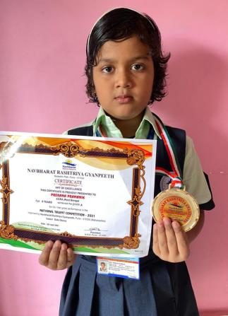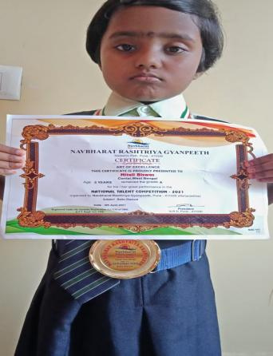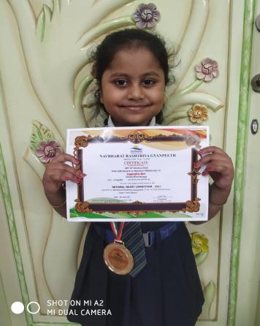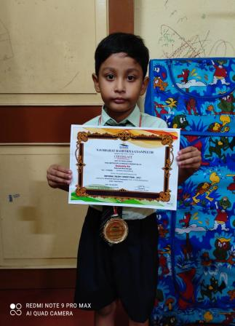
INDIA STAR ICON KIDS ACHIEVERS AWARD- ADITI HUTAIT AND LAGNAJITA GIRI
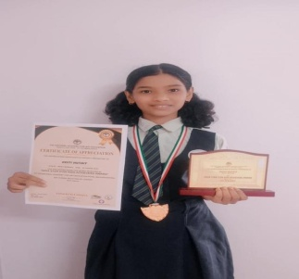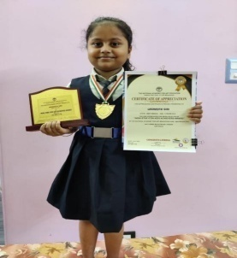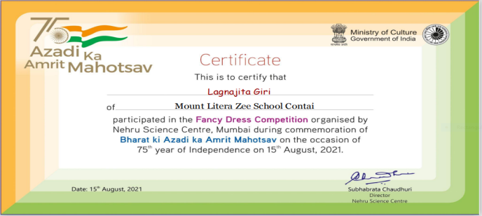
ONLINE INTERNATIONAL DANCE COMPETETION- RITAJA KARAN
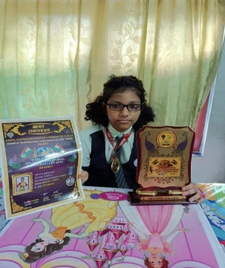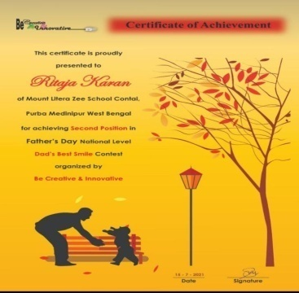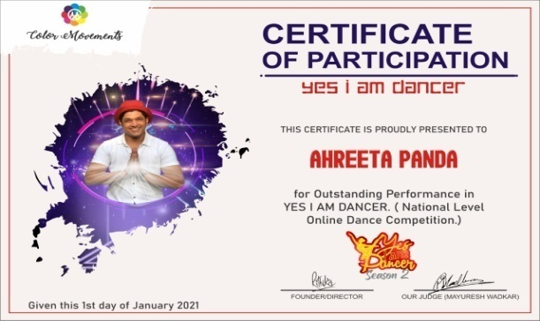
INTER SCHOOL SOLO DANCE COMPETETION
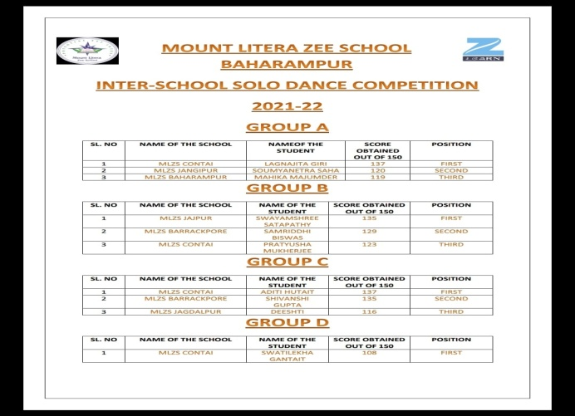
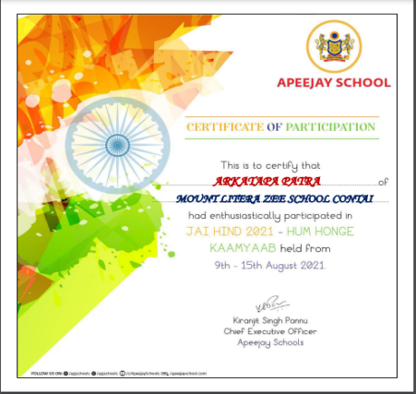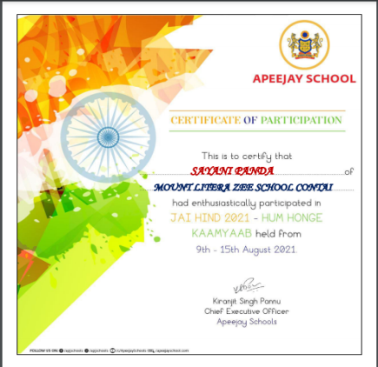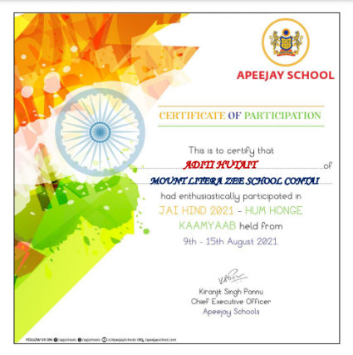

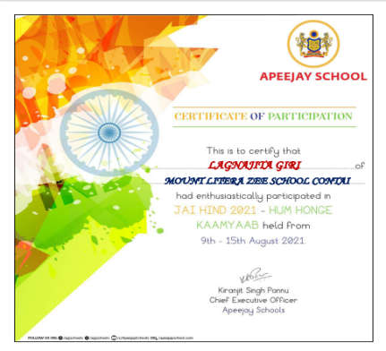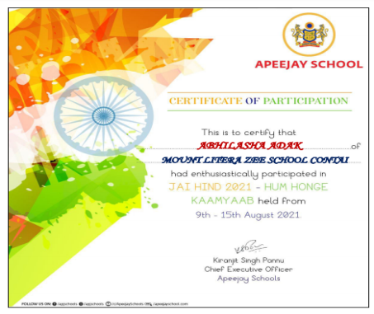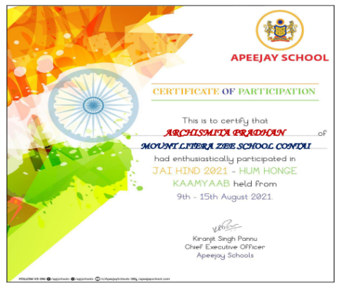
DEPARTMENT: HINDI
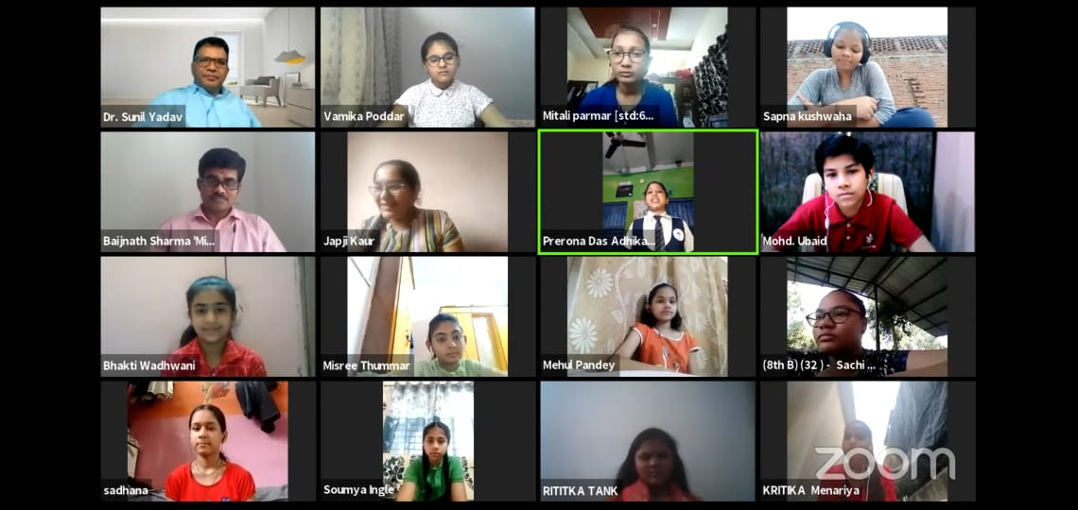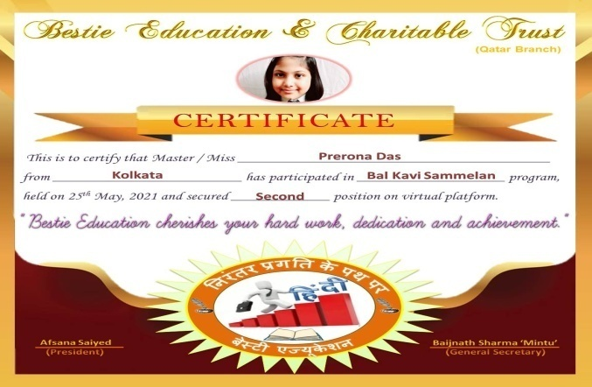

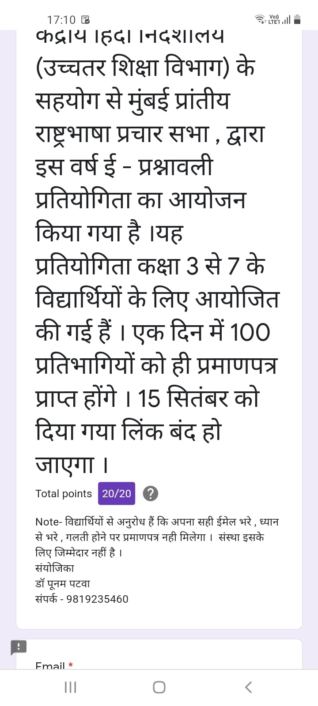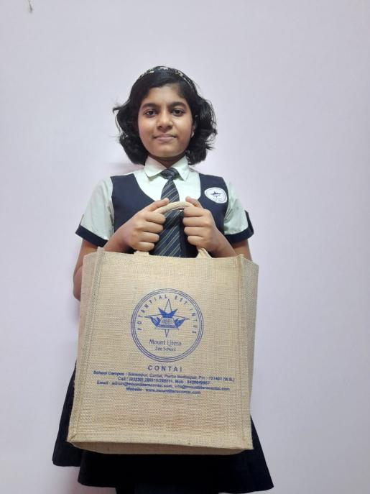

DEPARTMENT: ART
Arkatapa patra got the third position in a drawing competition, organised by Apeejay school, park street. Theme was My India in 2051.
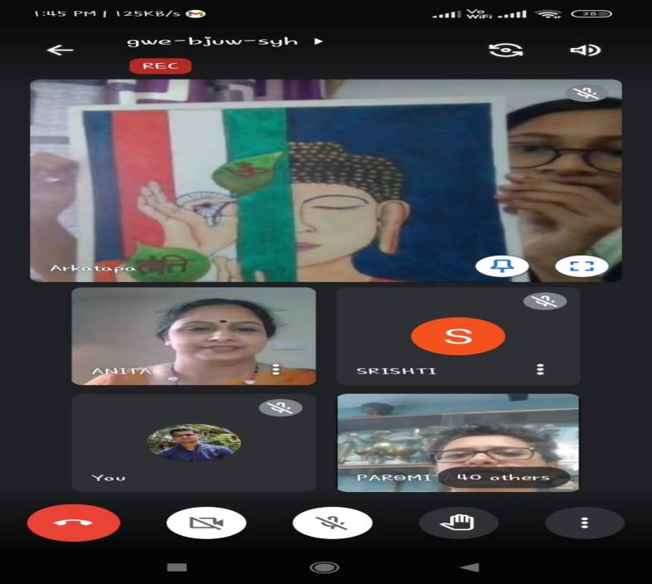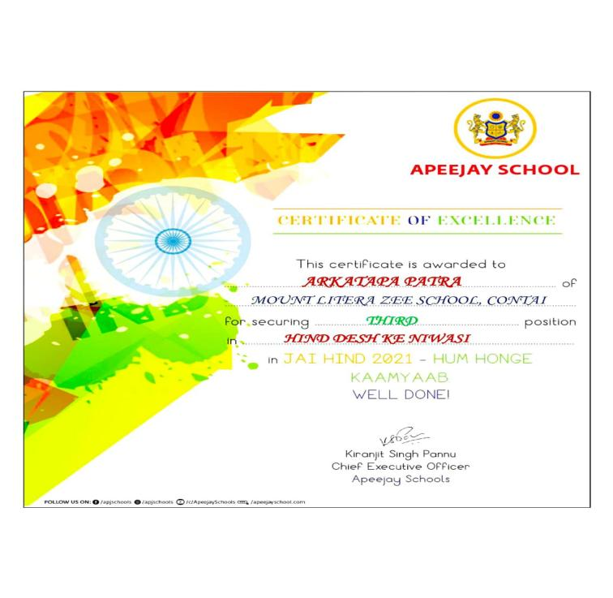
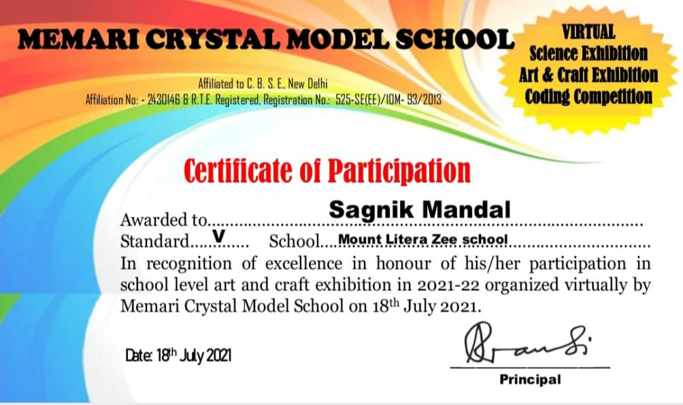
Sanik Mandal- Art Exhibition Maha Shivaratri Program- ART COMPETITION -Ayushi Nanda
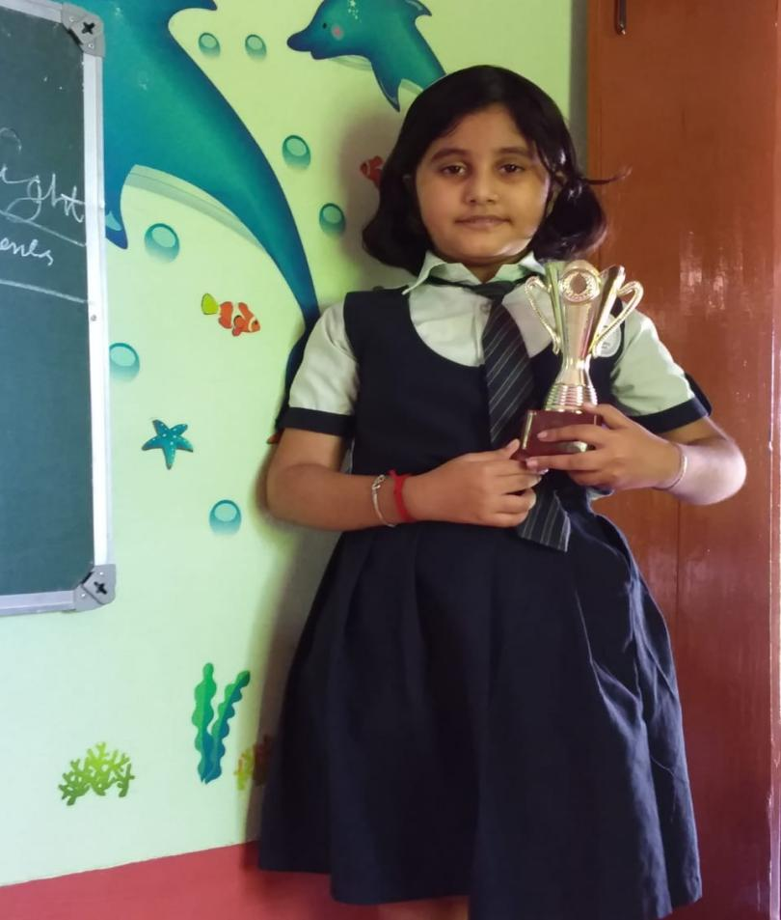
DEPARTMENT: IT
Certificate of participation in Advance excel training
Shreyanka Satpathy-Std11,
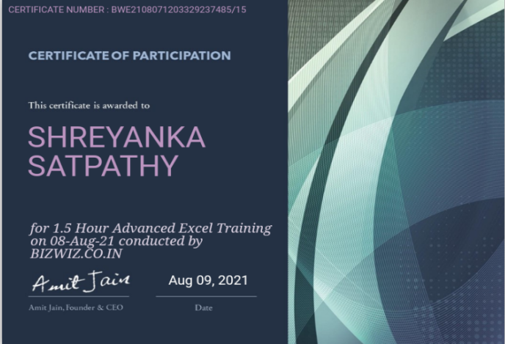

DEPARTMENT: PHYSICAL EDUCATION
Raima Bera ,Grade 7 selected for yoga from West Bengal, in Indian star icon kids achievers award by the national academy for Art education ,Pune
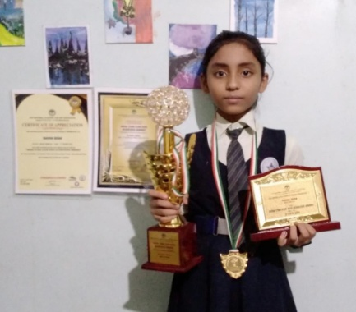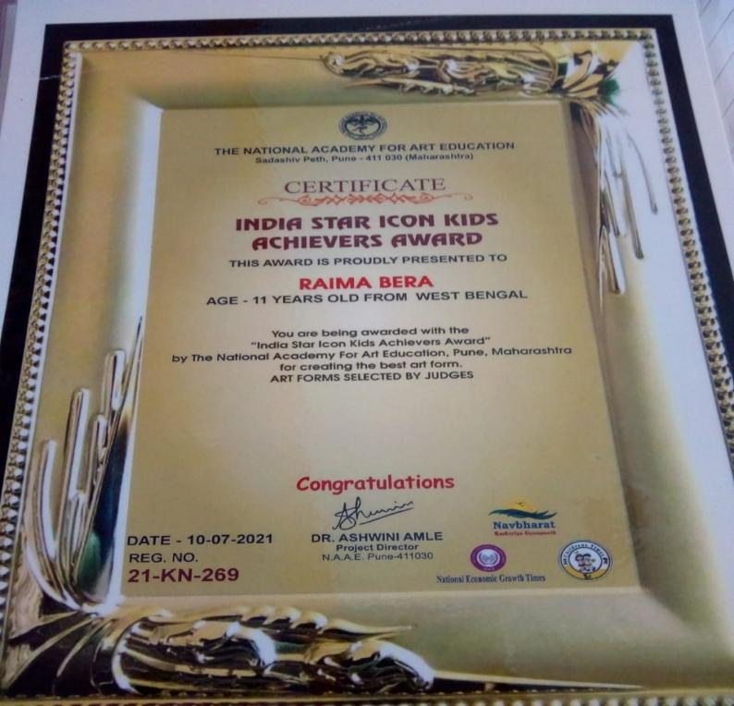
CATEGORY: PRIMARY AND MIDDLE SCHOOL ,SEONDARY AND HIGHER SEONDARY
DEPARTMENT: SCHOLASTICS
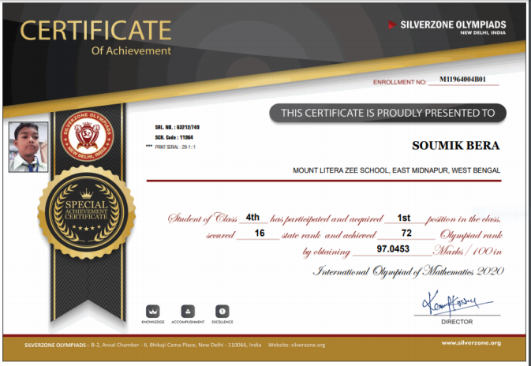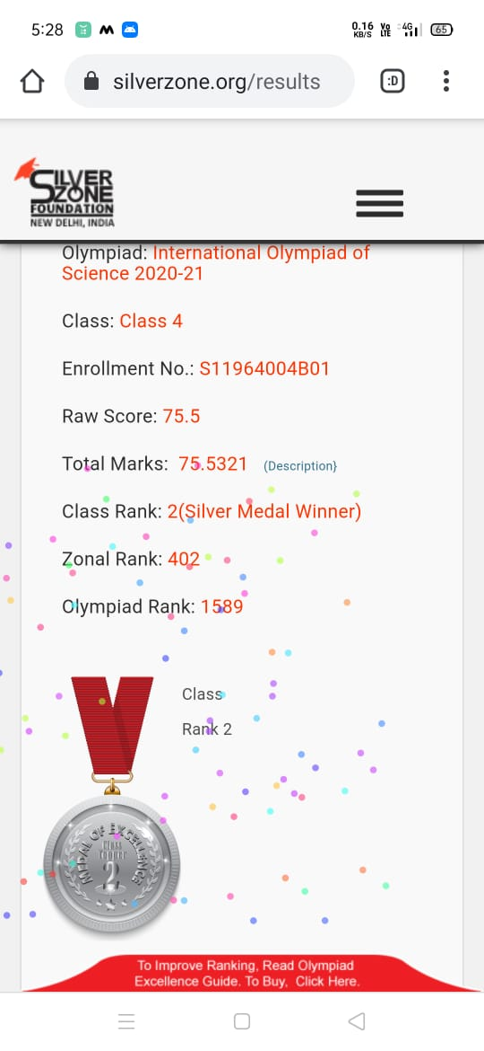
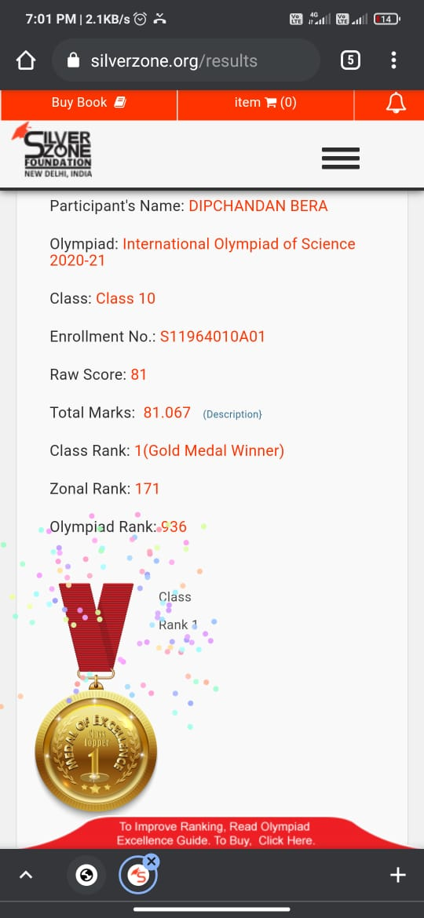
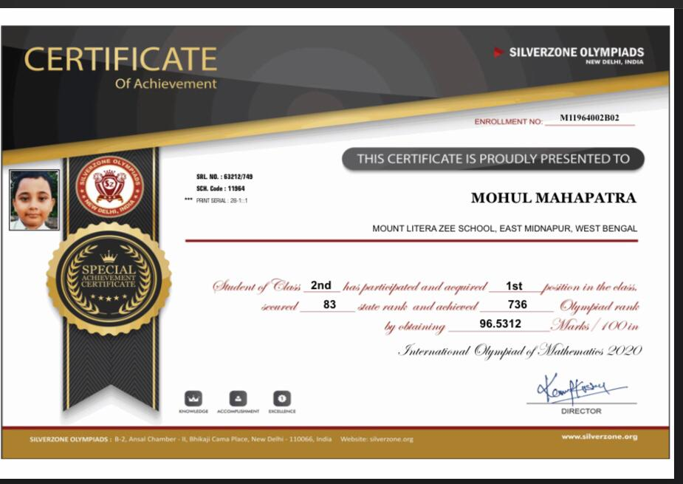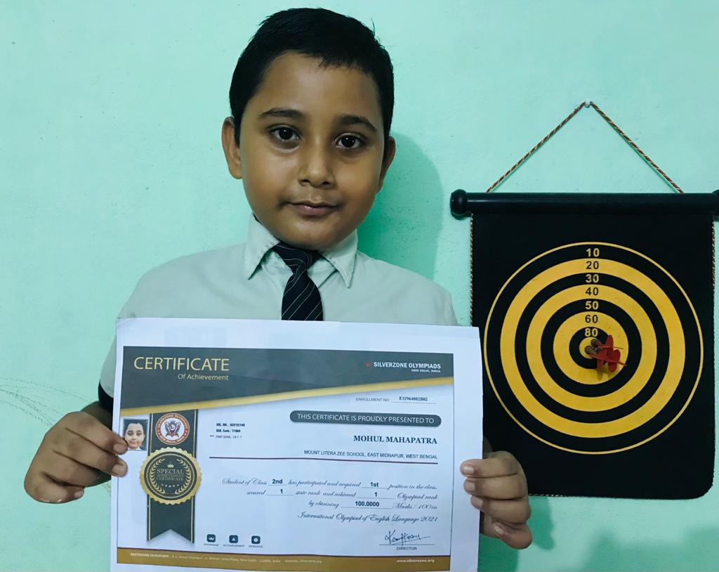
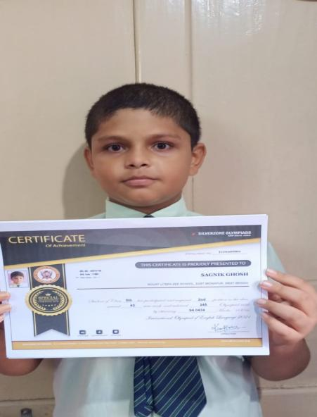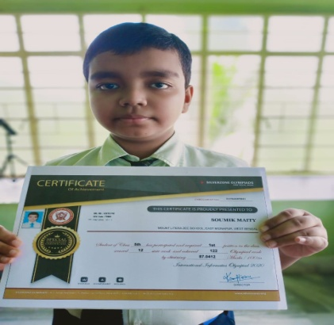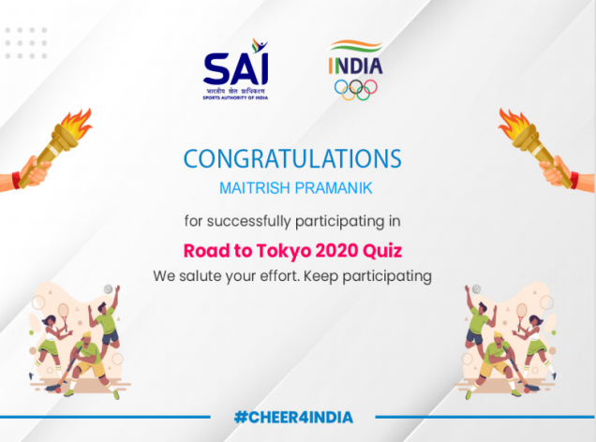

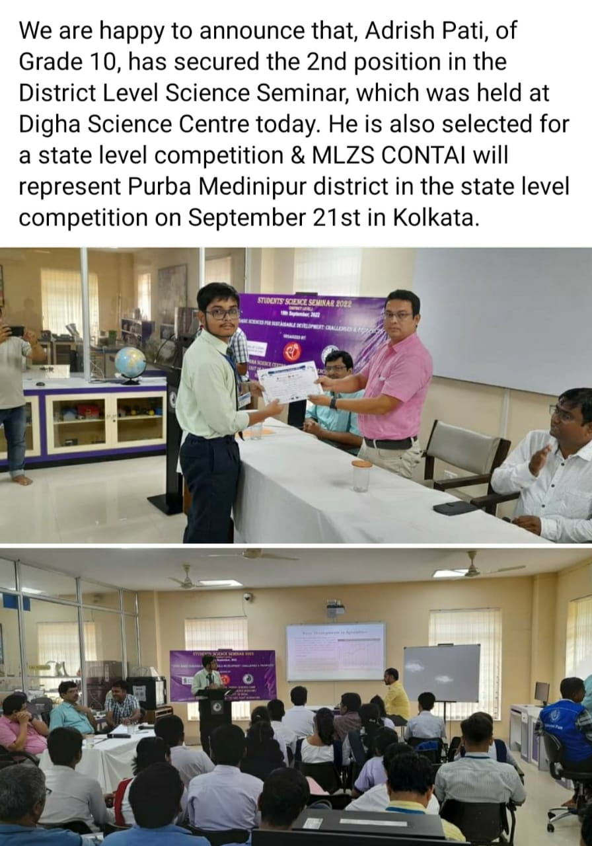
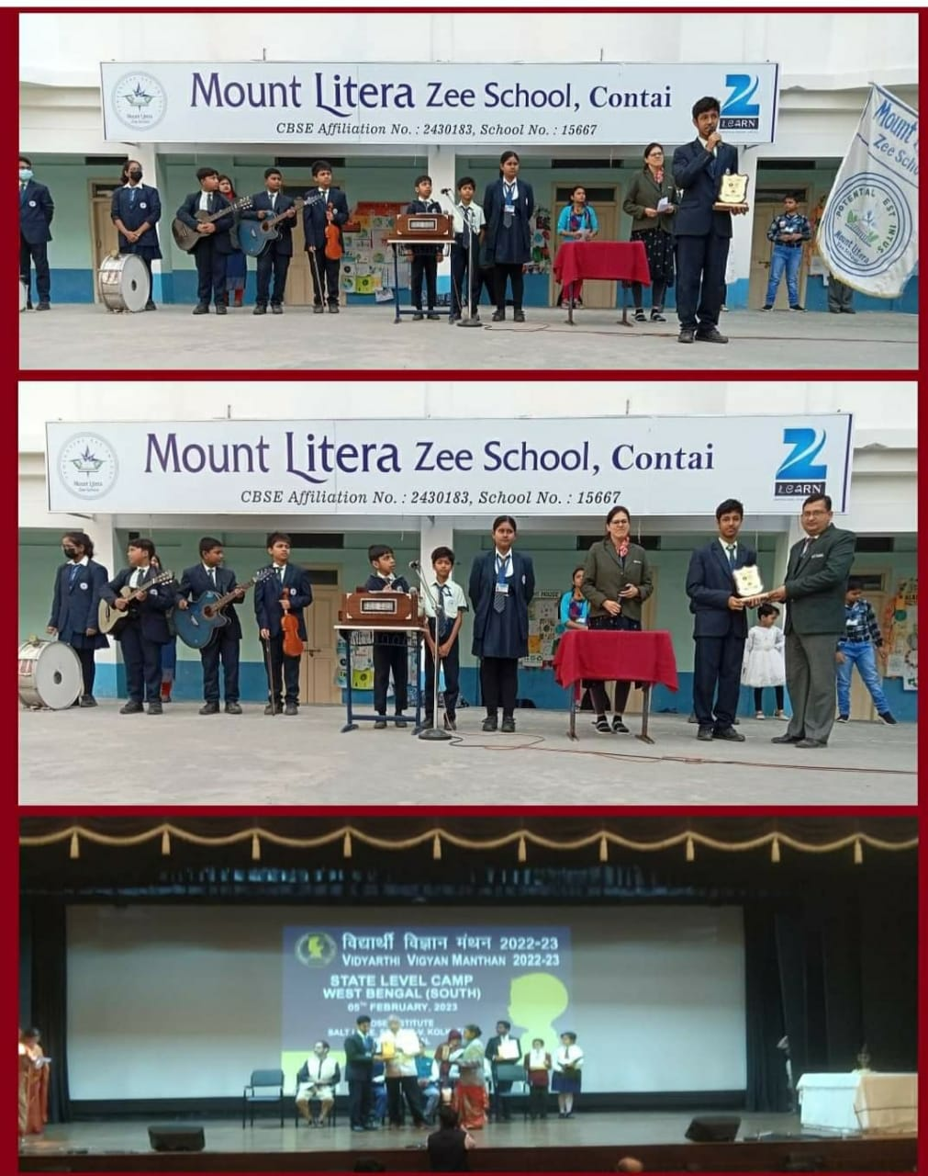
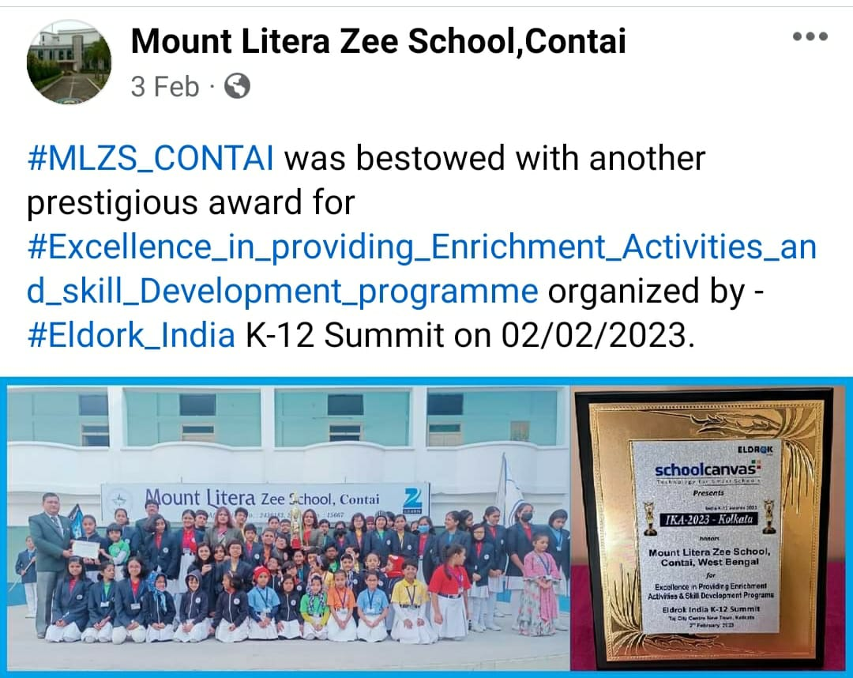

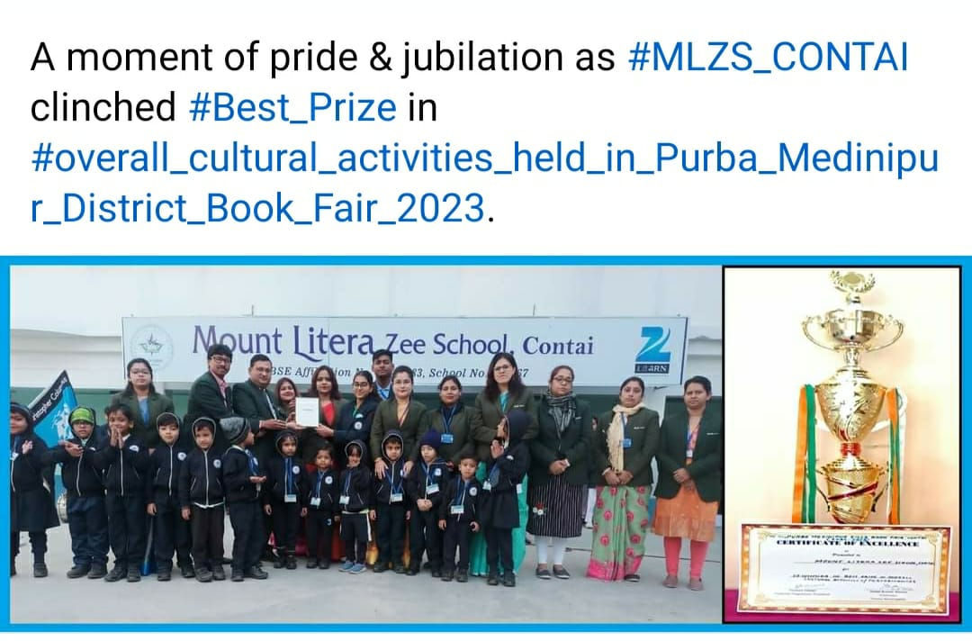

RELEASE OF INDEPENDENCE DAY CELEBRATION OF MLZS ,CONTAI IN THE YOUNG METRO OF TELEGRAPH
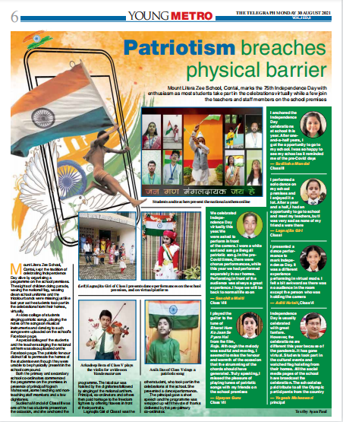
ACHIEVEMENTS OF SCHOOL MEMBERS
National women excellence award for solo dance by the national academy of art education
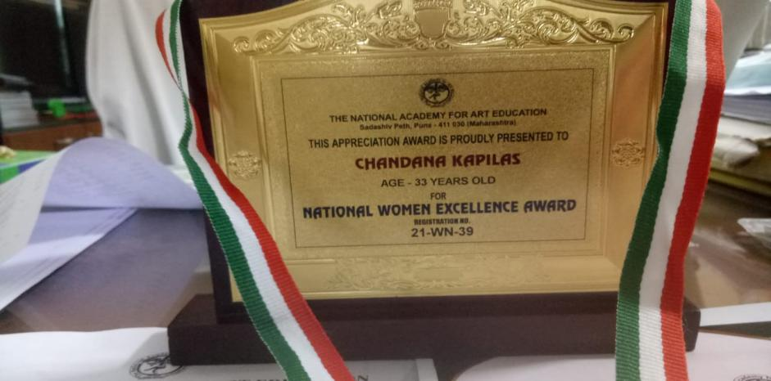
Hindi Ratna Samman Nari Gaurav Samman
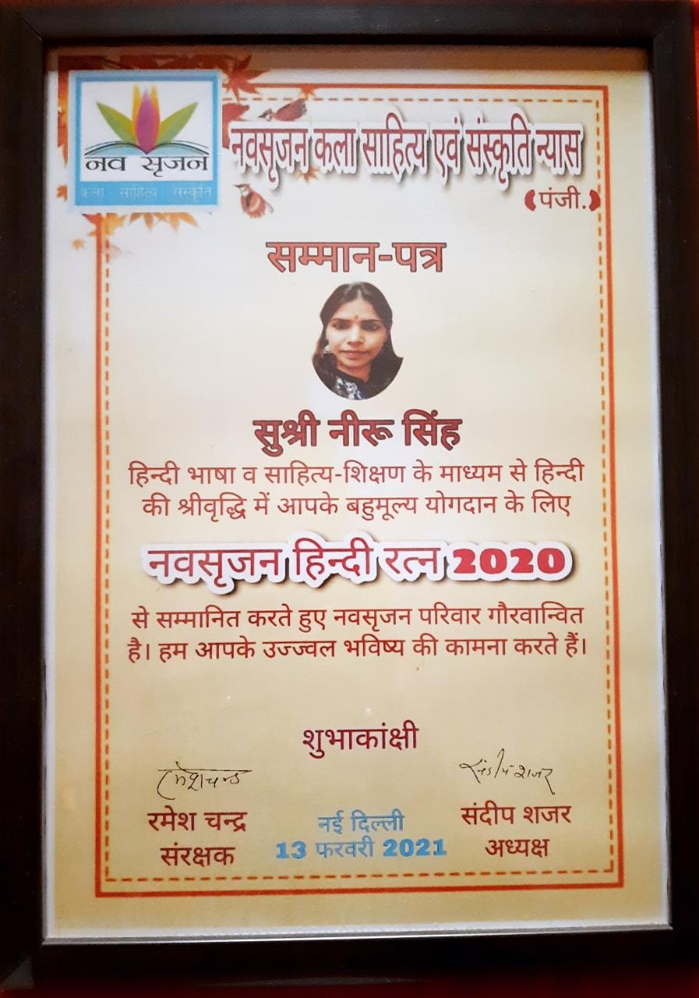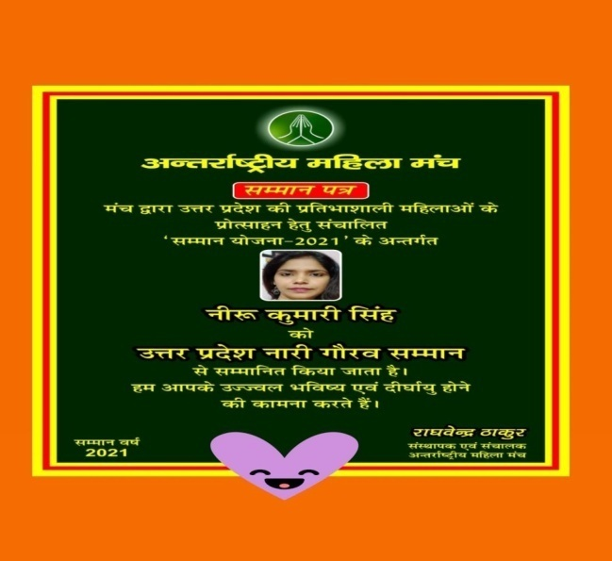
Sahitya Srijk Samman Hindi Sewi Samman
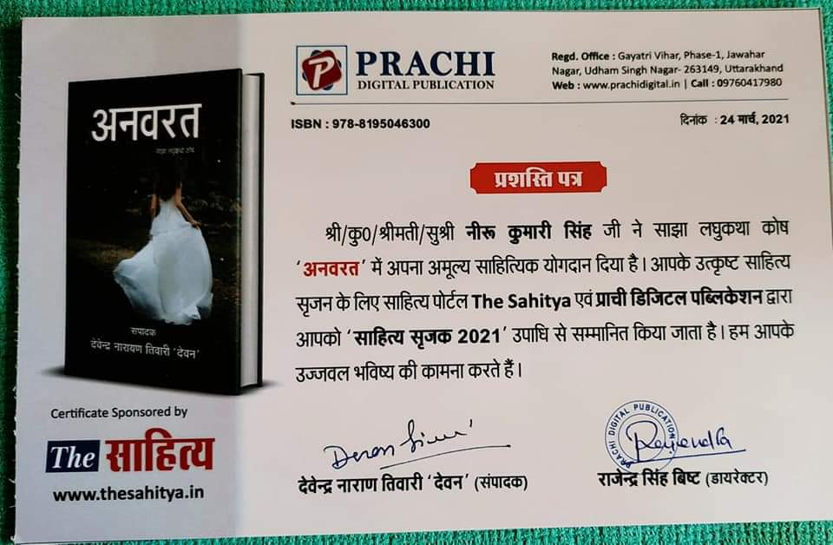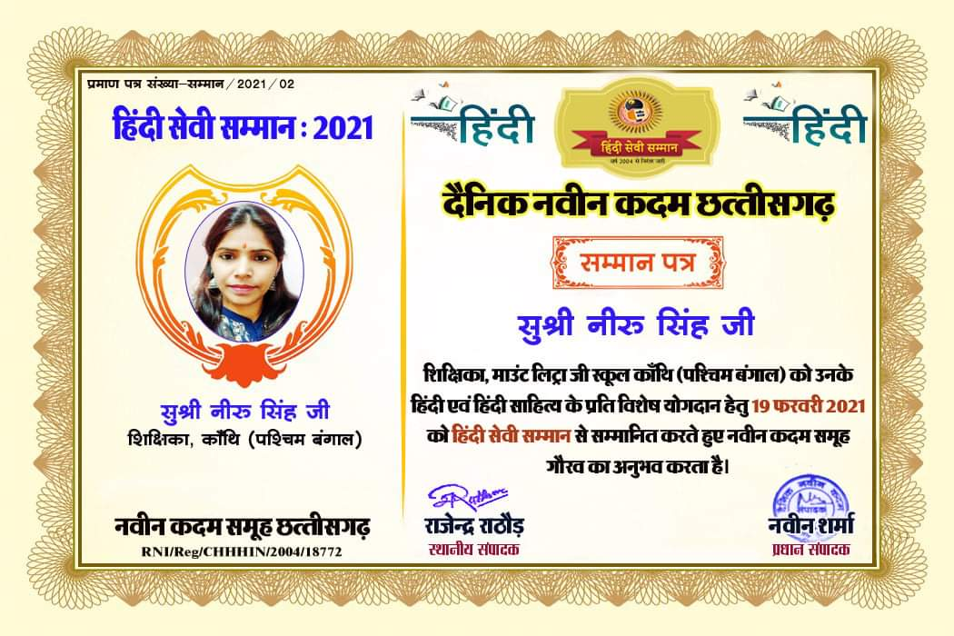
Samrth Hindi Shikshka Samman Hindi Academic Sewa Ratn Samman
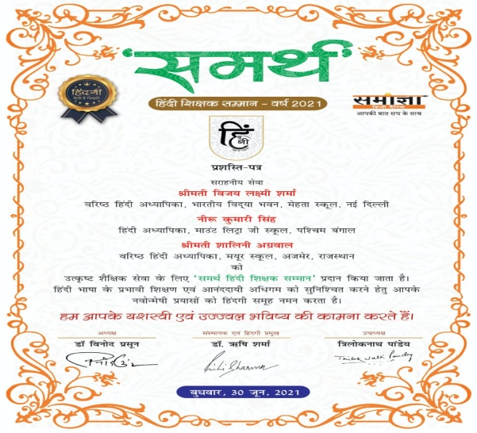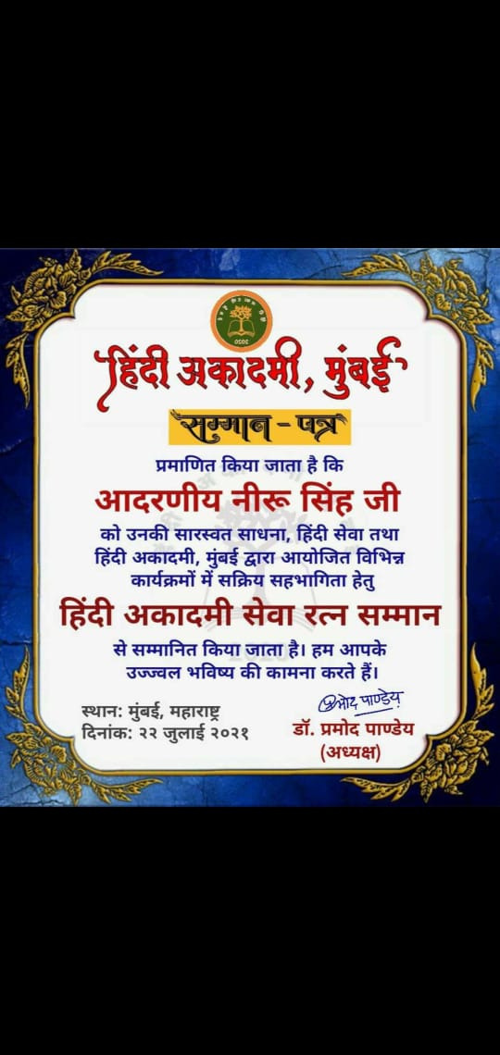

Prneta Samman
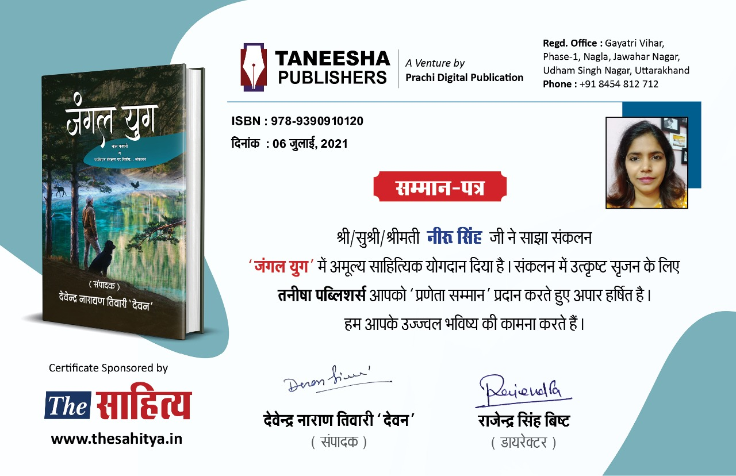
International Teacher Excellence Award

GLANCE OF ACTIVITIES ORGANIZED BY CLUBS , HOUSES& COMMITTEE

NAME OF THE CLUB:ECO
IN-CHARGE:PALLABI BISAI
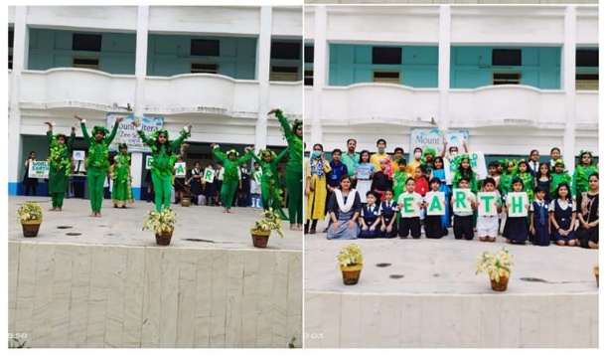
Date:22.4.22
Activity Specification: World Earth Day
Let us take a vow to protect mother earth by doing our parts. Every small effort counts.
#Mount_Litera_Zee_School_Contai observes #Happy_Earth_Day

Date:5.6.21
Activity Specification: World Environment Day

#2022_WORLD_ENVIRONMENT_DAY theme is #only one earth’. Aspirants of #Mount_Litera_Zee_School_Contai urges all to assist in ecosystems’ recovery which have been degraded by deforestation, pollution, and other human activities. They appealed all of us to be more humane and caring towards our #Mother_Earth through planting trees,
greening cities, changing diets or cleaning up rivers and coasts, and rewinding gardens. #Rich_biodiversity and #green_ecosystems yield immense benefits.
N.B. The ongoing pandemic has reminded us of the harm we have caused to Mother Earth and how essential it is to protect the environment.

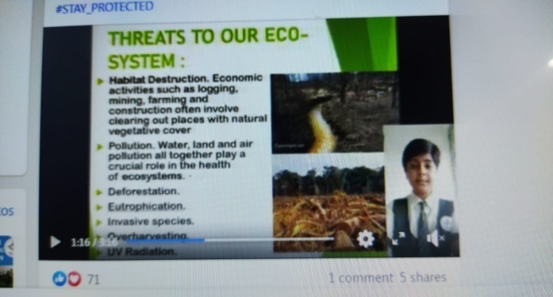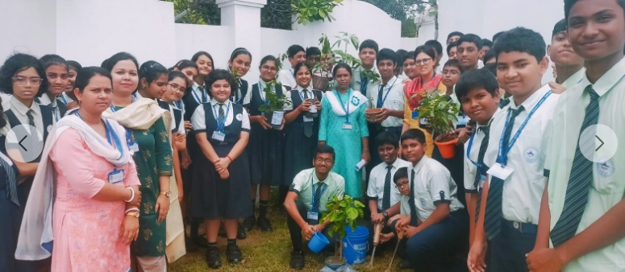
The environment provides us with essential resources to sustain life on Earth.
"Let us nurture the Nature
To have a better Future"
-It is the message that our #tiny_tots want to spread among the whole world. To spread awareness and preserve such resources for the present and future generations the little kids had participated in #tree_plantation and collage making activity. Let us join our hands together with them to make our Earth evergreen.

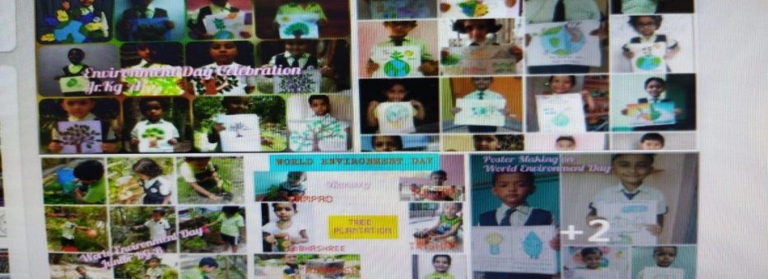
Date:3.7.22
Activity Specification: Vanmahotsav
There are a lot of good ways to celebrate, and the easiest requires a simple resolution on our part.
#Plastic_pollution is a global catastrophe and ironically it is a man-made one.#Van_Mahotsav week is celebrated by #Eco_Club of #MLZS_CONTAI to encourage people globally to plant more and more trees as they are being cut down on a large scale to meet our endless greed.

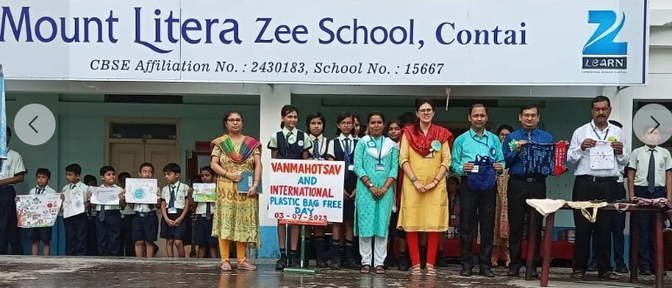

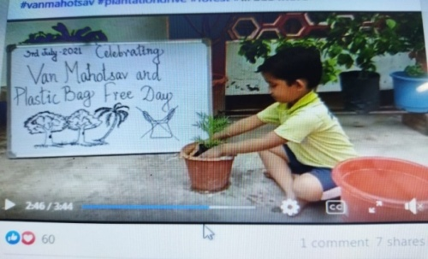

#Van_Mahotsava is celebrated as a festival of life.The name Van Mahotsava means 'the festival of trees'. Van Mahotsav is an annual pan-Indian tree planting festival, occupying a week in the month of July.
Keeping this fact in mind and considering the covid 19 situation, the #Eco_Club of #Mount_Litera_Zee_School_Contai has taken plenty of initiative celebrating the same.
The students from primary, middle school and secondary section students have shown their great effort in #go_green, #quiz and #panel_discussion to make the occasion a grand one. Some glimpses are shared.

Date:14.12.21
Activity Specification: National Energy Conservation Day
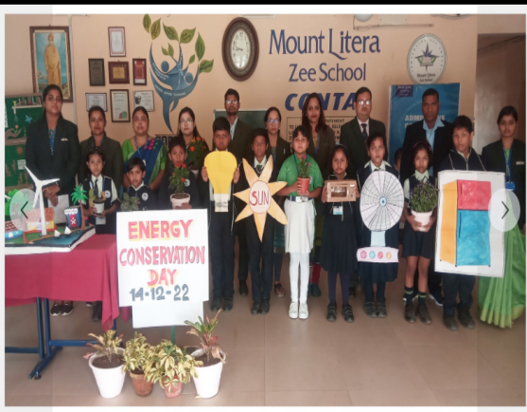

Every year on 14 December the National Environment Conservation Day is celebrated with an aim to raise awareness among the general public about the importance of energy conservation and energy efficiency. In the current scenario of the issues of overpopulation and its deadly consequences, the emphasis on conservation of energy for the long term via sustainable sources of energy has picked up steam. It is important for each every one of us to be aware of the fact that the energy available is limited and without judicious utilization of this limited energy available the future will not be bright, rather it is going to be a dystopian one.
Keeping this view in the mind, today, the Eco-Club of Mount Litera Zee School, Contai has taken many initiatives to sensitize the community and our students have tried to spread the awareness by doing small activities.
A moment of pride and jubilation for #MOUNT_LITERA_ZEE_SCHOOL_CONTAI.
#MLZS_CONTAI was conferred with #The_Ambuja_Neotia_Award_for_Excellence_in_Maintenance_and_Eco_Friendly_Initiatives by the #Telegraph_Foundation. #Congratulations to the entire team.
#Telegraph_school_awards_2022 #MLZS_CONTAI
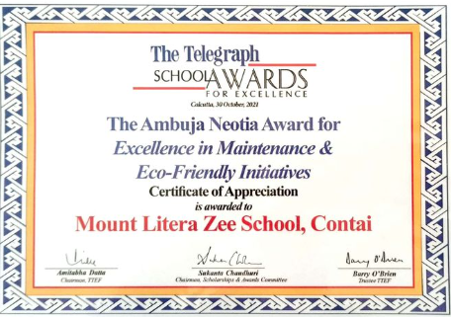

NAME OF THE CLUB:HERITAGE
IN-CHARGE: FALGUNI CHAKRABORTY
Date:29.07.20
Activity Specification: World Tiger Conservation Day
"Where tigers thrive, it is a sign that the ecosystem is healthy".
#Mount_Litera_Zee_School_Contai celebrated #International_Tiger_Day to raise public awareness and support for tiger conservation issues. Ardent literans of #MLZS_CONTAI sensitized us all to be sensible and contributing to the act of #SAVING_THE_TIGERS.
#A_Heritage_club_initiative
#MLZS_CONTAI #SAVE #SAVE_ECOSYSTEM

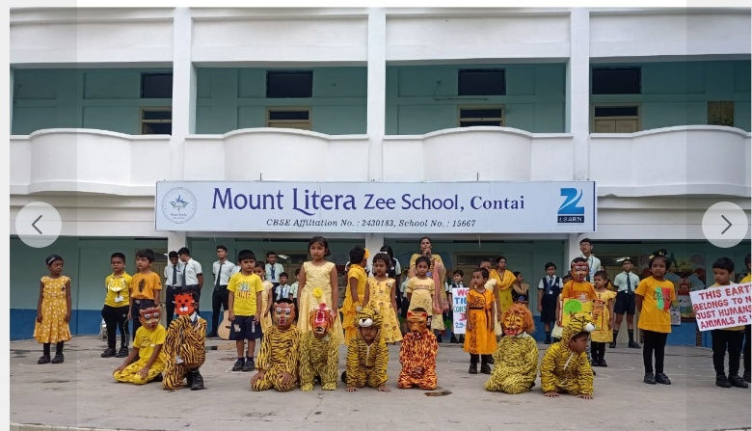

Activity Specification: World Friendship Day
Few relations in earth never die.(F-R-I-E-N-D)
#Friends are the ones who bring happiness and merriment into our lives. We do need them on our happy and sad days. With their support, life becomes a little easier to live. #MOUNT_LITERA_ZEE_SCHOOL_CONTAI celebrated #International_Friendship_Day where our aspiring literans forge a strong bond of friendship amongst them delightfully.

NAME OF THE CLUB:HEALTH
IN-CHARGE: Dr. YOGESH MAHESWARI
Date:6.8.21
Activity Specification: World Hiroshima Day

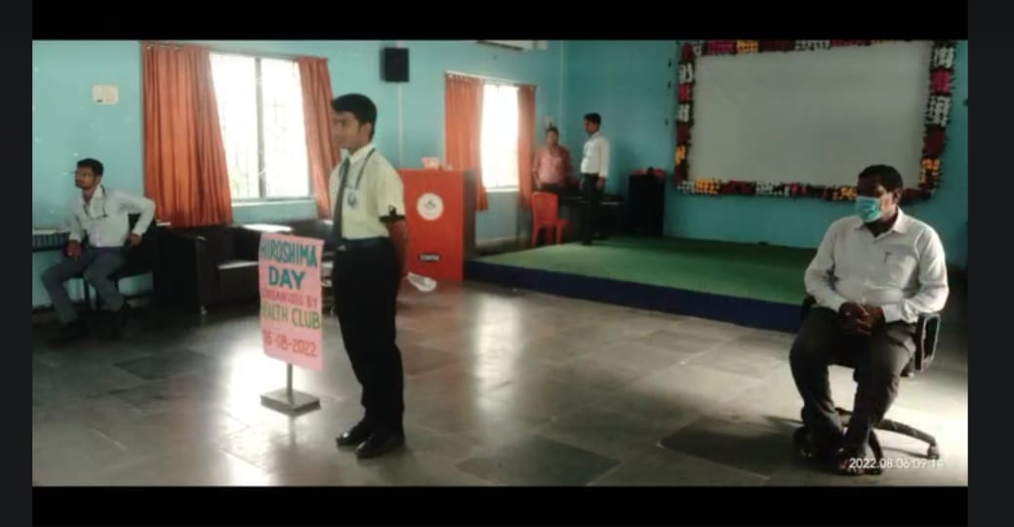

Hiroshima Day is observed annually on 6 August to commemorated the remembrance of the bombing attack on Hiroshima and Nagasaki.Hiroshima Day 2020 marks the 75th year of walking the path of the atomic bomb. The day aims to promote peace politics against the war It is a reminder of the day when a nuclear weapon was used during an armed conflictbetween two countries, and the lives it took while razing a city to the ground. The effects of the atomic bomb that was dropped by the US on the city of Hiroshima, Japan in 1945, saw a large number of people continue to die months after the incident, and most were innocent civilians. In memory of the day and of those who lost their lives, August 6 is marked yearly as Hiroshima Day.
Today Health Club of Mount Litera Zee School,Contai has shown the tribute to those innocent victims who has sacrificed their life due to this terrific bombing attack held during 2nd World War. The observation of this day is a crucial message to humanity about the importance of World Peace and a means to spread the awareness about the destructive nuclear weapons. So, let us join hands and work together to reach this global aim. In this regard Class 5 students have showcased their talents in various activities to make the day successful.
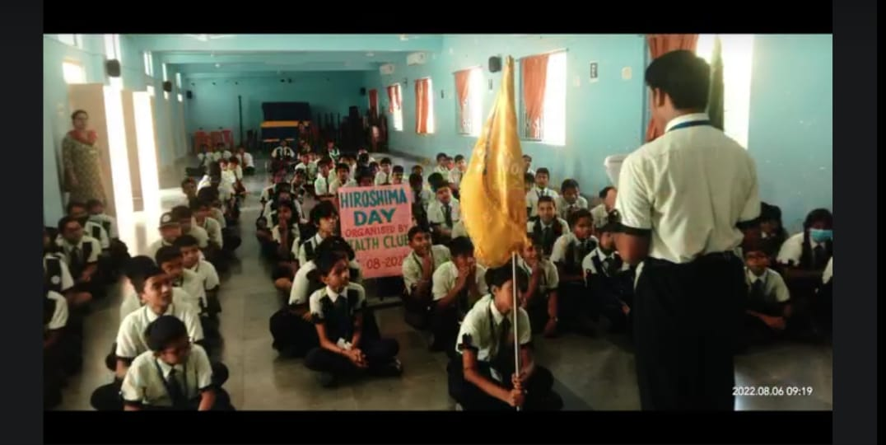
NAME OF THE CLUB:READING
IN-CHARGE: ABHIJIT DUTTA
HINDI DEPARTMENTAL HEAD: NIRU KUMARI SINGH
Date:14.09.21
Activity Specification: Hindi Diwas
“हिंदी हमारे राष्ट्र की अभिव्यक्ति
का सरलतम स्रोत है। "
‘ सुमित्रानंदन पंत '
हिंदी के महत्व को समझते हुए #माउंटलिट्राजीस्कूलकाँथि के बच्चों ने हिंदी पखवाड़े में हिंदी के प्रति अपनी जागरूकता और रुचि का प्रदर्शन विभिन्न तरीकों से किया।
अपने कार्य द्वारा बच्चों ने यह संदेश दिया कि “विश्व में लगभग 80 करोड लोगों की यह भाषा सरल, सुंदर और मनोहारी है।”
#हिंदी_दिवस की आप सभी को हार्दिक शुभकामनाएँ।
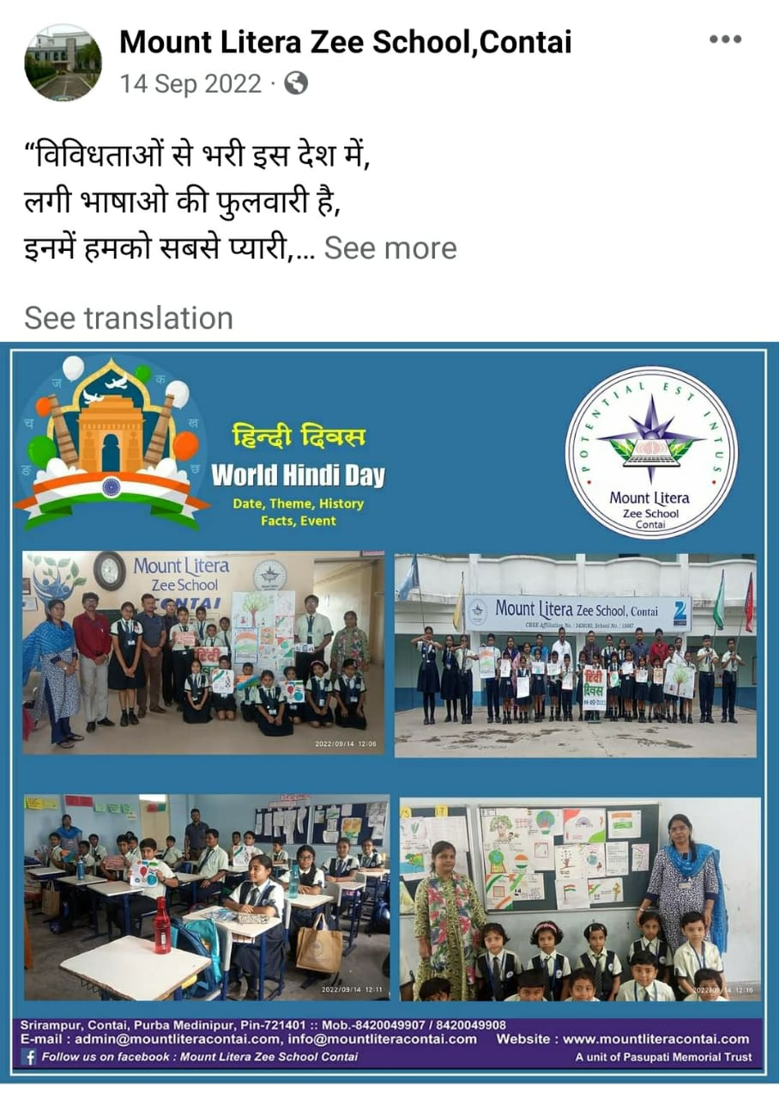

NAME OF THE CLUB:READING
Date:11.11.20
Activity Specification: National Education Day
With reference to circular vide Acad-85/2020 , under the directives of CBSE, Reading Club of Mount Litera Zee School, Contai observed National Education Day to commemorate the birth anniversary of Maulana Abul Kalam Azad, the eminent educationalist and the first education minister of India with an objective to promote balanced minds and developing the education system of India. Two students from our institution beautifully delivered message laying stress of this very day and the proposed National Education Policy 2020 with its salient features.
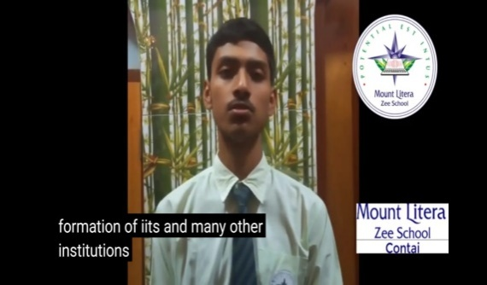

NAME OF THE CLUB:SCIENCE
IN-CHARGE: MOUMITA DAS
Date:2.8.22
Activity Specification: 160th Birth Anniversary of Prafulla_Chandra_Ray
#Mount_Litera_Zee_School_Contai celebrated 160th Birth Anniversary and paid tribute to the “#Father_of_Indian_Chemistry”- #Prafulla_Chandra_Ray, a well-known Indian scientist and teacher and one of the first “modern” Indian chemical researchers.

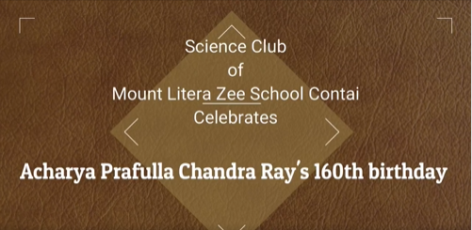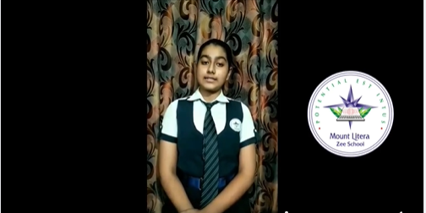
Date:2.12.21
Activity Specification: World Computer Literacy Day
This is the celebration not only to educate everyone to learn and understand the language and the usage of computer but also by this day we are celebrating the #invention and #benefits of #Computer in our life. The theme of the #World_Computer_Literacy_Day_20212 is- "Literacy for human-centred recovery: Narrowing the digital divide".
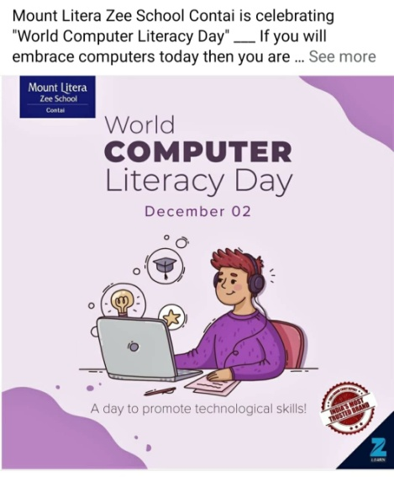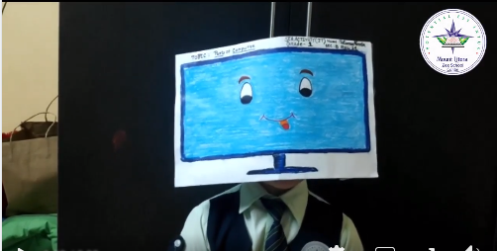

NAME OF THE CLUB:SCIENCE
Date:22.12.22
Activity Specification: National Mathematics Day
" An equation means nothing to me unless it expresses the thought of God"- Shri Srinivasa Ramanujan.
Legendary mathematician Shri Srinivasa Ramanujan made extraordinary contributions on mathematical analysis, number theory, infinite series & continued fractions. Respectful tribute to the Man who knew infinity on National Mathematics Day. Celebrated to mark the birth anniversary of Shri Srinivasa Ramanujan, the day offers us an occasion to remember the tradition of excellence..
# National Mathematics Day

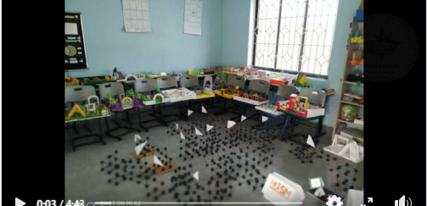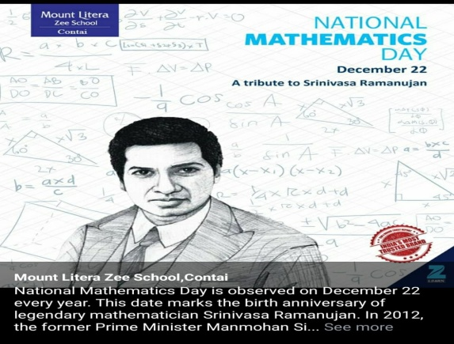

NAME OF THE CLUB:SCIENCE
Date:27.2.22
Activity Specification: National Science Day
Every year National Science Day is celebrated on February 28 to commemorate the discovery of prominent scientist Sir. CV Raman.In 1928 the great Indian Scientist Sir Chandrasekhara Venkata Raman discovered a phenomenon known as Raman Effect and was awarded by Nobel Prize in the year 1930, which was the first Nobel Prize in India in the field of Sciencefor his huge contribution.To mark this discovery every year on 28th February National Science Day is celebrated through out India.This academic year the theme of the day was based on Future of STI: Impacts on Education, Skills and Work.
By keeping this view in the mind Today the NATIONAL SCIENCE DAY was observed in Mount Litera Zee School, Contai.The day was started with a delightful speech delivered by grade 10th student Diphandan Bera based on the significance of National science day. Then one collage display by Srija Das of grade 10th. Then it was accompanied by a short quiz based on Dr. C.V Raman where the selective students of 8th to 12th have participated with full enthusiasm.
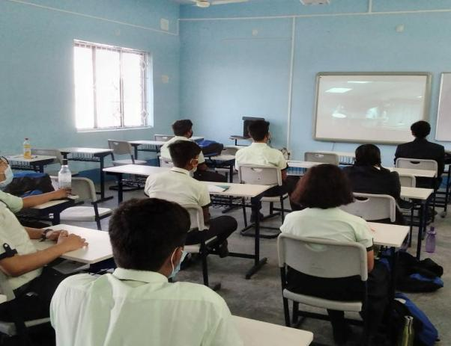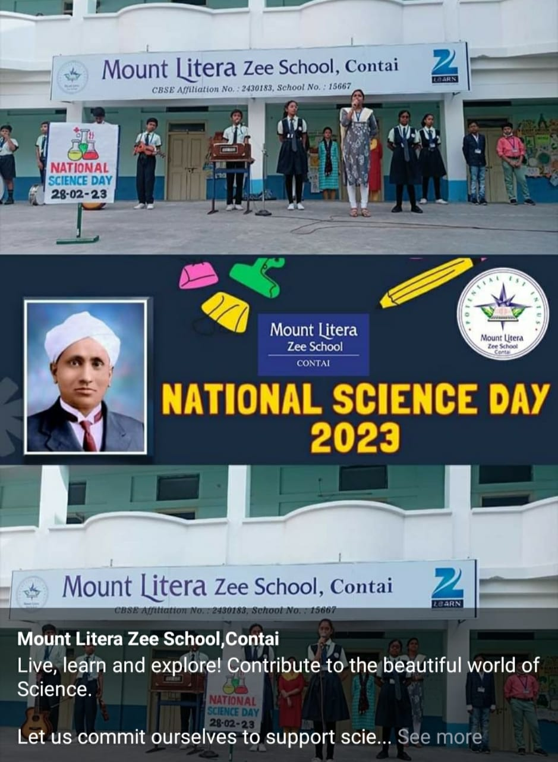

NAME OF THE CLUB:INTEGRITY
IN-CHARGE:NABANITA PANDEY MAITY

We ourselves feel that what we are doing is just a drop in the ocean,
But the ocean would be less because of that missing drop- Mother.
#Mother_Teresa, who devoted her life to help the poorest of the poor, the destitutes and orphans, is a symbol of humanity. Also known as #Saint_Teresa of Kolkata, a recipient of Nobel Peace Prize for her charity work.
#Mount_Litera_Zee_School_Contai pays homage and obeisance to her immortal soul on her #Birth_Anniversary.
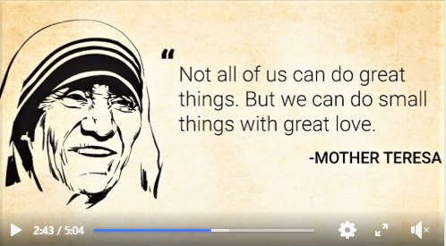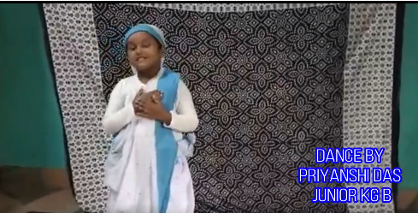
Date:2.10.22
Activity Specification: International Day of Nonviolence
India always advocates the spirit of peace and non-violence. MK Gandhi was a pioneer in this field. His birthday, 2nd October, has been regarded and observed as an #International_Day_of_Nonviolence. Students of #Mount_Litera_Zee_School_Contai (#Integrity_Club)are always inspired to uphold the spirit of Non-violence in the truest manner. Let's all celebrate the International Day of Non-violence.
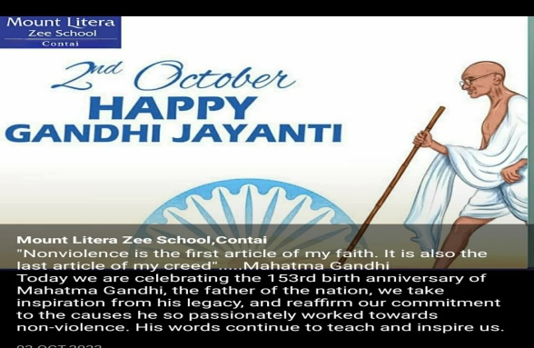
Date:10.12.22
Activity Specification: Observation of Human Rights Day
All human beings are born free and equal in dignity and rights. The students of Integrated Club of MLZS Contai is celebrating Human Rights Day. The participants uphold the spirit to spread the message of equality among the masses. This is the time to spread the message that is human right based approach to development is the best way to reduce inequalities. This is the time to sing for human rights.

NAME OF THE HOUSE:LEONARDO DA VINCI HOUSE(RED HOUSE)
IN-CHARGES :RAHUL DAS AND MEGHA PRADHAN
Month: APRIL
Activity Specification: New resolutions
Beginnings always bring happiness-it may be the beginning of a new topic or of a new session or of a new habit no matter what the situation is. In this alarming hours, #Mount_LITERA_ZEE_SCHOOL_Contai thought of giving a new start to 2022-23 with a new hope that everything will be as usual soon. We'll get our old days back. Again the cackle of the students will be there. Members of #Leonardo_da_Vinci_House have taken part to make this initiative a successful one.
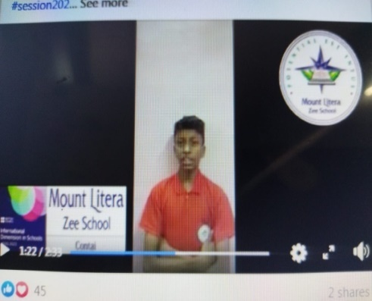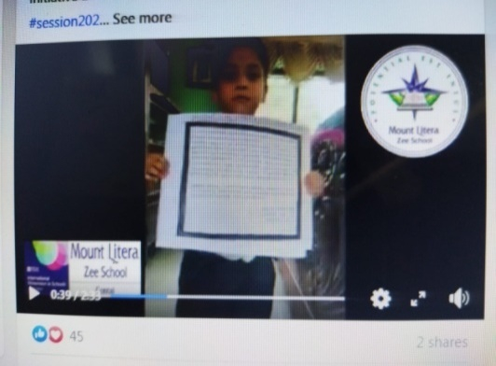

Month: JUNE
Activity Specification:SAVE WATER
Life depends on water but the reservoir depends on us.
Members of #Leonardo_da_Vinci House want to spread the message that 'No Water, No Life'.Let us all take a promise that we'll utilize this beautiful gift of nature without wasting a single drop of it.
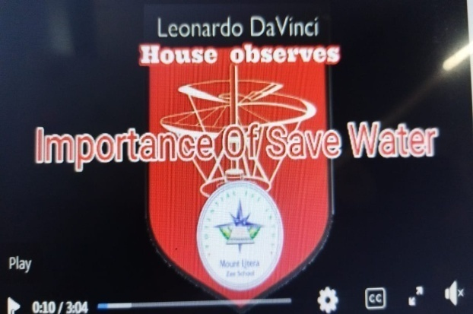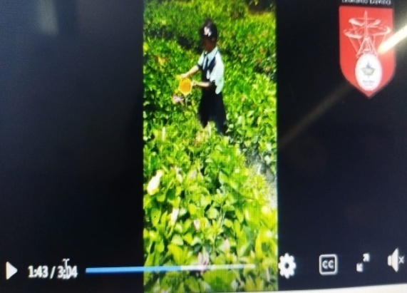
Month: November
Activity Specification:Safety
'Safety' is a very short word but it contains a great meaning. It should always be our first priority whether we are at home or outside. If we ignore it ,within a fraction of second it can snatch our life. We never should take it as an option. Unsafety practice is a peril to our lives.
All the members of Leonardo da Vinci House from Mount Literally Zee School, Contai again thought to work upon this new topic, 'Safety' to spread the awarness specially during this critical situation among the students as well as the society. All the students took active participation in it to make it a successful one. Parents also supported us a lot with their unique thoughts
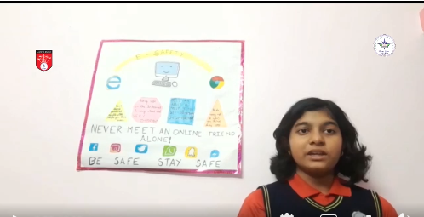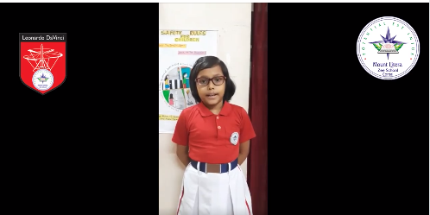

NAME OF THE HOUSE:MAHATMA GANDHI HOUSE(GREEN HOUSE)
IN-CHARGES :PRITAM ROY AND SUJATA DAS MAHAPATRA
Month: JUNE
Activity Specification:SAVE WATER
The unmindful wastage of clean drinking water is one of the most serious threats in front of the world.Members of #Mahatma_Gandhi house of #MLZS_CONTAI had beautifully exhibited their presentation and reminded us of imminent dangers awaiting.

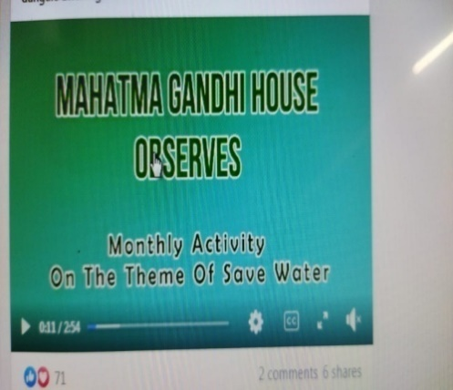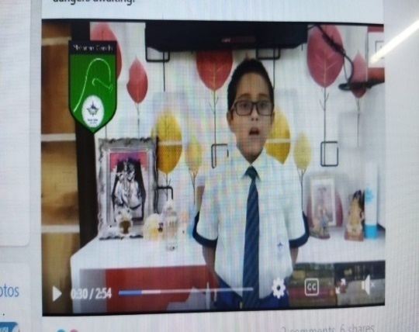
Month:JULY
Activity Specification: Festives of Monsoon

India is embraced for its rich cultural heritage which is an outcome of its ethnic diversity. We celebrate everyday through each other's festivals.This monsoon although we are socially apart due to the pandemic but our passion lies the same. Mahatma Gandhi house(middle school section) has made a small attempt to fill our lives with happiness and urges everyone to break the shackles of fear and negativity because we believe this moment too shall pass and India will shine again.The students have presented a collage video of monsoon festivals, being celebrated all over India, on a musical note to give a positive vibe to everybody in this present situation

NAME OF THE HOUSE:ALBERT EINSTEIN HOUSE(ORANGE HOUSE)
IN-CHARGES :MOHAN TRIPATHY AND NABANITA P MAITY
Month :APRIL
Activity Specification: New resolutions
#Albert_Einstein_House took up a resolution to minimise #world_hunger index with their small endeavour. Our mission is to extend helping hand to hungry people, understanding the nature of poverty, setting up local #food_bank, planting trees to increase food production and increasing consciousness about nutrition education.
May we and hungry people throughout the world enjoy a happier and more prosperous time to come.
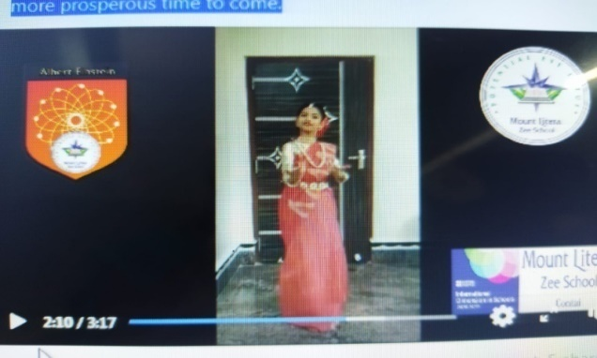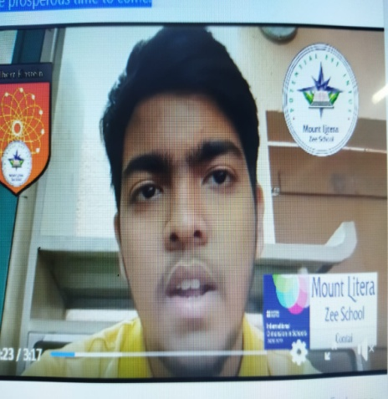

Month :MAY

"When you look into your mother's eyes, you know that is the purest love you can find on this earth."
#Mount_Litera_Zee_School_Contai celebrates and acknowledges all mothers' unconditional love, tireless efforts and utmost dedication on occasion of #International Mother's Day.
#An_initiative_by_Albert_Einstein_House
#MLZS_CONTAI_2021_22

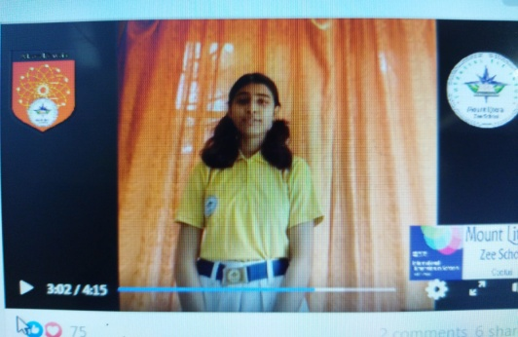
Month:July
Activity Specification: Festives of Monsoon

Albert Einstein house celebrated monthly activity Festives of Monsoon for the month of July,2020. In this activity Srinwan Manna of grade-V delivered a short speech about various types of festivals in our country. Bidisha Panigraghi and Rishika Barman of grade -X performed dances on Rabindra sangeet. Last Swsweta Maiti recited a poem “Ashar” by Rabindranath Tagore. Overall, this activity done very nicely.
Month: August
Activity Specification: Patriotism

We achieved our much desired liberty on 15th August through the struggle of freedom fighters.August gives us an opportunity to pay homage to the known and unknown freedom fighters. Students of #Albert_Einstein_House ,#MLZS_Contai paid homage to the Indian patriots and freedom fighters through different activities.
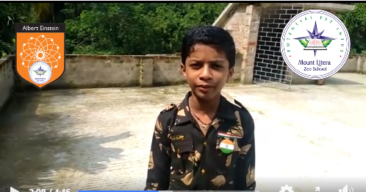
Month: November
Activity Specification:Safety
Albert Einstein house celebrated monthly activity on safety for the month of November,2020.In this activity Tamisha Ghorai of grade- VII delivered a speech,Mounika Maity of grade-II(B) recited a rhyme and Aditi Hutait of grade -V(B) performed a dance.
Month: December
Activity Specification:Time Management
Albert Einstein house celebrated monthly activity on Time Management for the month December2022.In this activity Mahiruha of grade-VIII(B) delivered a speech,Ahannik of XI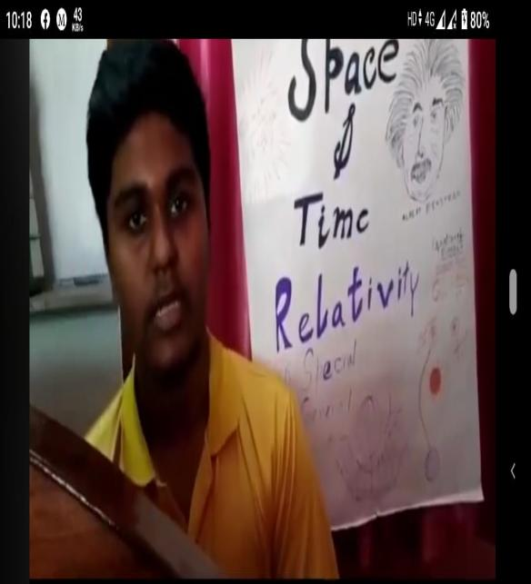 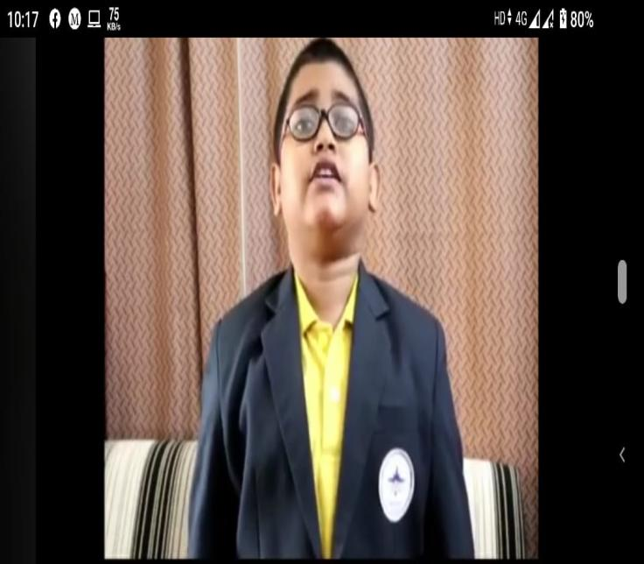
NAME OF THE HOUSE:CHRISTOPHER COLUMBUS HOUSE
IN-CHARGES :SURAJIT DAS AND ALAKANANDA DEY
MONTH: MAY
Activity Specification: New resolutions
"It's a new world, it's a new start
It's alive with the beating of young hearts
It's a new day, it's a new plan."
----Bryan Adams
Resolution is a commitment in which a person resolves to continue good practices, changes an undesired trait or behaviour and accomplishes a goal.
With the onset of a new academic session, it's our time to take new resolutions to make a healthier, happier and prosperous days ahead.
#A_Christopher_Columbus_House_enterprise
#Believe_on_your_potentials #Redefining_your_goals #MLZS_CONTAI
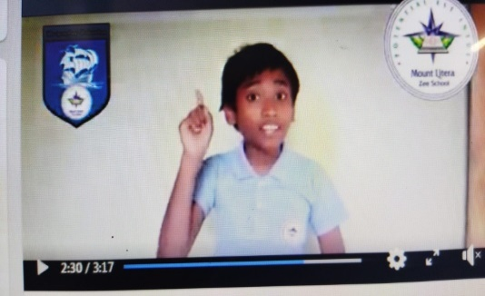

Month:June
Activity Specification: Save Water
Students of Christopher Columbus house have roused the awareness about saving water. They delivered speeches on the importance of Water. They showed how we can save water and reuse it. Water is the most valuable and we can’t live without it. Now a days, people waste water randomly. As

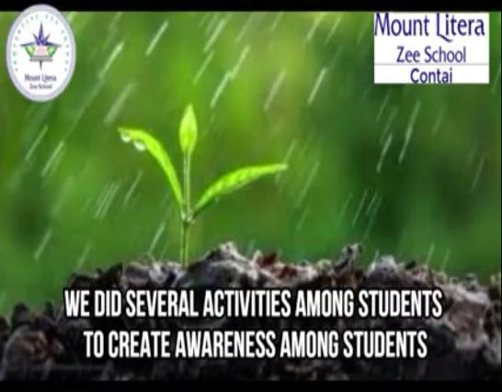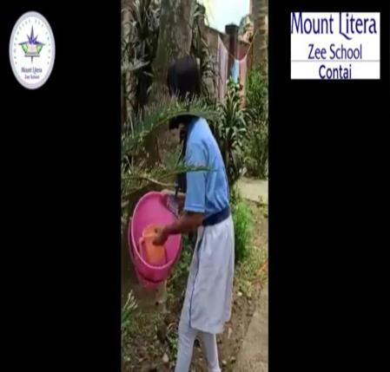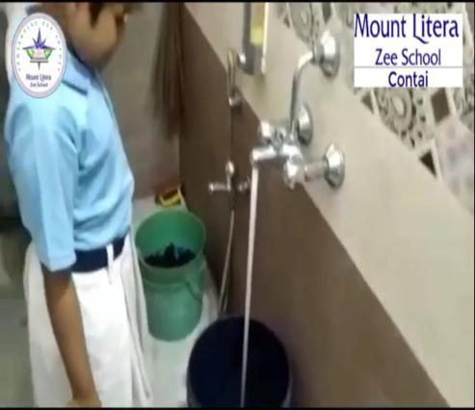

Month:July
Activity Specification: Festives of Monsoon

"To celebrate a festival means: to live out, for some special occasion and in an uncommon manner, the universal assent to the world as a whole." - Josef Pieper
India is a land of festivals. #Christopher_Columbus_House tried to represent some of the monsoon festivals as a monthly activity.
Hope these festivals will enlighten and bring positivity for all of us and repel negativity.

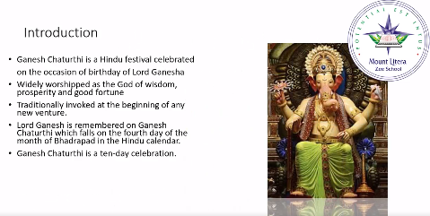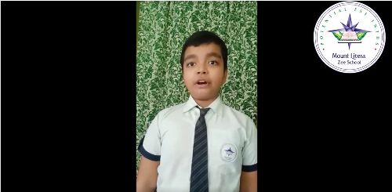
Month:October
Activity Specification:Unity in diversity

#Christopher_Columbus house of #MLZS_CONTAI observed the monthly theme on #Unity_in_diversity with much grandeur and grace.

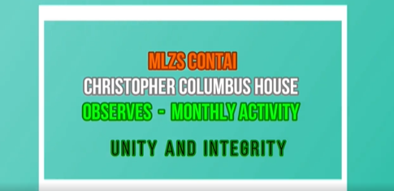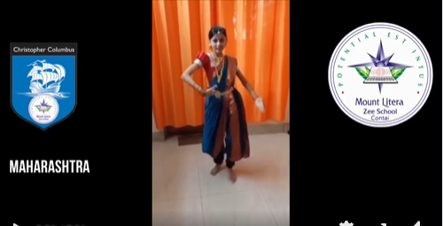
Month: November
Activity Specification:Safety
The students from Christopher Columbus house represented some information on the theme Safety. They highlighted some important topic like Home Safety, Diwali safety, Kids Safety, Internet safety & Road Safety. They have expressed their opinion and concern about the above mentioned themes. Their point of view is right and evident. We should follow rules of Safety live long and save our atmosphere.

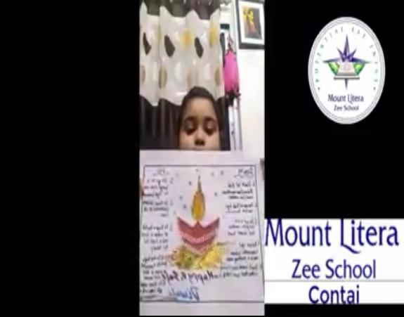

Month: December
Activity Specification:Time Management
The students on the behalf of Christopher Columbus house have performed impressively attractively their monthly topic ‘Time Management’. They have recited on it. This is a good choice for students as an activity. The students will be able to learn how we can manage time in our daily life. This is the great part of our life. Time leads one to focus on success.
Time is precious, which plays a significant role in everyone’s life. We all are aware of the proverb “Time and Tide wait for none.” No one can discontinue the flow of time. Once the time is gone, it never comes back. So, it is vital to respect the time and consume it wisely.
#A_Christopher_Columbus_House_Initiative
#Importance_of_Time_Management
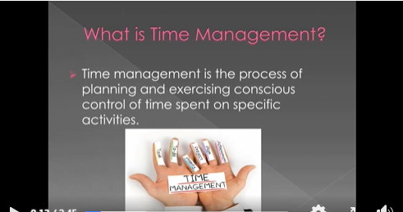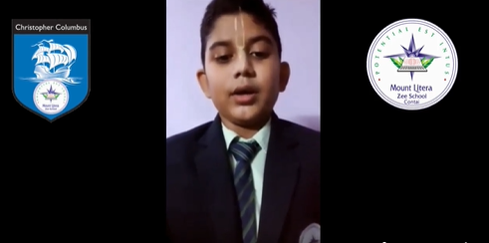
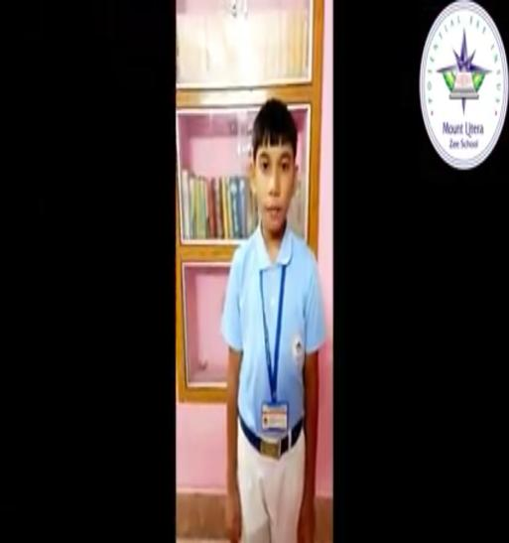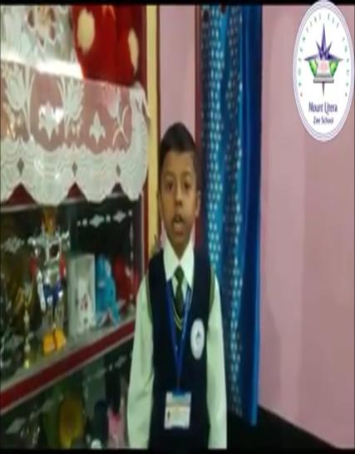

International Collaborations

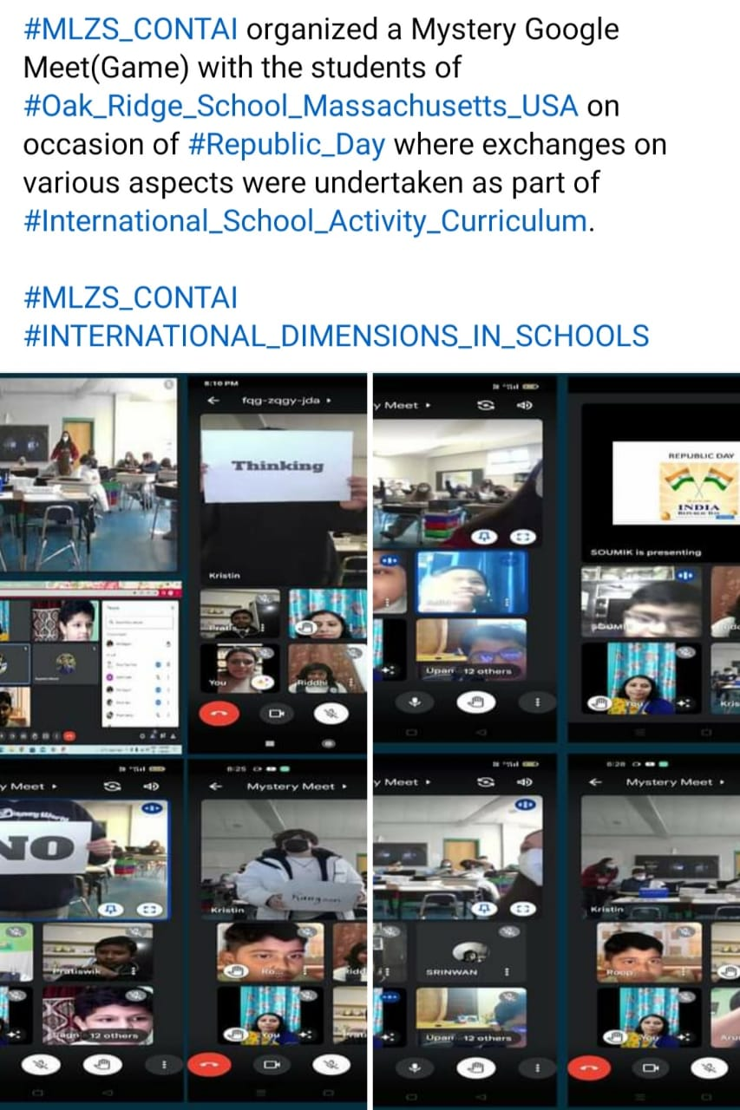

Keeping in mind the holistic development of our students, we have always worked towards giving them ample opportunity to inculcate all the life skills needed to be successful in today’s world. Towards the end, I thank the supportive management whose continuous support to our ideology of education has enabled the school to come this far. Teachers and the entire staff members also deserve applause for their tireless efforts in implementing the route map of imparting quality education here. I also extend my heartfelt thanks to the parents of our students who have shown unflinching faith in us by giving us the profound opportunity to transform their children into truly useful citizens of the future world.
With that, let us foresee a world of universal singularity where our children are going to be the propellant of this change and the world shall be a beautiful place to live in. With this I seek God’s blessing for each one of us to keep accomplishing new heights of success. I end my report with these famous lines by John Dewey, “Arriving at one goal is the starting point to another”

It is rightly said “The secret of all great undertakings is hard work and self-reliance.”
I avail this opportunity today to express a heartfelt thanks to our revered Chairman Sir of the school Mr.Chintamoni Mondal Sir for his trust in our hard work and self reliance, which has boosted our efforts to make our school one of the best schools. And I also thank our revered Vice Chairman Mr. Shubhajit Mondal Sir and Director Sir Dr.Saikat Mondal Sir , Administrator Madam Mrs. Sutanuka Mondal Madam and Rector Madam Mrs. Aparna Mondal Madam for their constant support and guidance in all matters concerning school management.

Thank You!!
Jai Hind.
Dr Yogesh Maheswari
Principal

MLZS, Contai

